Bruce A. McKenzie and George H. Foster,
Extension Agricultural Engineers, Purdue University
Sherwood S. DeForest, P.E.
Agricultural Engineer, Consultant

Contents

Introduction

Air Flow System Performance and Energy Relationships
Grain depth vs. fuel efficiency
Grain depth vs. air flow
Air flow resistance vs. air velocity
Grain depth vs. static pressure
Static pressure vs. fan type

Fan Performance Data
Packing factor
Fan efficiency
Determining specific fan performance
Air flow guidelines

Using the Bin Drying Performance Tables

Dryeration and Bin Cooling Performance Table and Guidelines
Using the performance table
Estimating required horsepower and surface area

Plotting Air Flow System Performance

Factors Affecting Fan Performance
Drying capacity vs. grain depth
Fines and air flow uniformity
Unusual fan horsepower ratings

Bin Drying Air Flow Rate Performance Tables

Crop-Fan-Match Computer Program Input Form

The sizing and application of fans are important in determining how much time is needed to dry and cool grain, what these jobs will cost and, in the final analysis, how much energy you will use. The less time involved in drying and cooling, the less your energy requirement will be. This, of course, will be reflected in a lower dollar cost for fan operation.
This publication presents data and tables for determining the air flow, system performance and energy relationships in bin drying and cooling. This will help you (1) to select the fan(s) for your particular application, and (2) through the use of example problems, to calculate the type and size of fans needed for your own grain facility.
From the information presented here, you should be able to answer such questions as:
* What fan horsepower is required to deliver the desired air flow for the grain depths and bin diameters I might use for the various bin drying, dryeration and bin cooling systems that are possible?
* How much air flow will my fan deliver for the bin diameters and grain depths I normally use?
* How will a change in fan horsepower or bin-fill depth affect the air flow per bushel and total air flow delivered in my bins?
* Shall I use a vane-axial (propeller) fan or a centrifugal fan for the bin diameter/grain depth application I plan?
The data presented cover fans that range in air flow delivery capacity from 0.33 to 10.0 or more cubic feet per minute per bushel (cfm/bu.) for drying and cooling shelled yellow corn andsoybeans. The data are applicable to fans for (1) dryeration or simple cooling, using air flow rates in the range of 0.5 to 1.0 cfm/bu., and (2) bin drying systems normally operating in the range of 1.0 to 10.0 cfm/bu. (No data are included for the air flow range normally used in aeration--typically 0.1 to 0.5 cfm/bu. for farm installations--and as low as 1/50th cfm/bu. for some elevator facilities.)

AIR FLOW, SYSTEM PERFORMANCE AND ENERGY RELATIONSHIPS
It is important to understand the relationship between grain depth and air flow resistance, velocity and static pressure conditions that occur in a bin. These relationships, in turn, have a marked effect on proper drying performance. If we understand the principles that make for efficient grain drying, we can best select the proper fan needed for operation--and thus conserve energy.

Grain Depth vs. Fuel Efficiency
A common error in operating bin dryers is to place too much grain in the bin. This is especially true in bin drying procedures that use partial fills but can occur in full-bin drying also.
All bin drying processes are energy efficient for bed depths 2 1/2 feet and above, in terms of using the heat applied to the drying air. Fuel efficiency does not change much as the bed depth increases above the minimum, but air flow efficiency does. Proper fan selection and application are prime contributors to overall dryer efficiency.

Grain Depth vs. Air flow
A common misconception among users of bin dryers is that air flow resistance through a bed of grain is independent of air velocity. Indeed it is not. Consider this: If you have 1000 bushels of grain to dry, there is a very great difference between drying it "1000 bushels wide and one bushel deep" and drying it "one bushel wide and 1000 bushels deep!"
The wider and thinner grain can be spread out, the less fan capacity-required to dry it in a given period of time. This principle is illustrated in Figure 1. The column of grain in the center of the bin has a cross-sectional area of exactly 1.25 square feet (sq. ft.). Each foot of column height contains one bushel (one bushel equals 1.25 cubic feet).
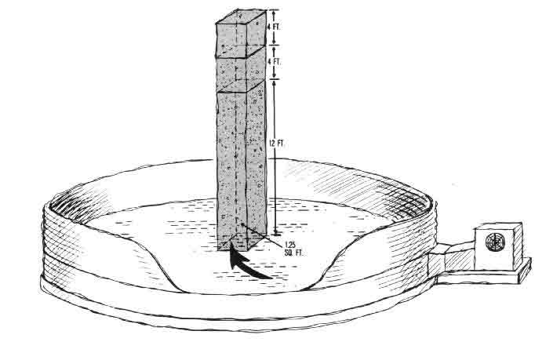

Figure 1. Grain bin cross section with a 1.25 square foot area grain "chimney" filled to 12-, 16- and 20-foot depths. Each foot of grain column contains one bushel. At an air flow rate of 2 cfm/bu., required air velocity for grain is 24 cfm at the 12-foot depth, 32 cfm at 16 feet and 40 cfm at 20 feet.
Assume that an air flow rate of 2 cfm/bu. is applied to the bin, flowing upward through the column of grain. A 12-foot depth, then, requires 24 cfm (2 cfm/bu. x 12 bu.). The air flow entering the column has a velocity of 24 cfm/1.25 sq. ft. of floor area or 19.2 feet per minute (fpm).
Adding 4 feet of grain and maintaining the same 2 cfm/bu. air flow level requires a velocity of 25.6 fpm (32 cfm ÷ 1.25 sq. ft.). Adding another 4 feet of grain and maintaining the same 2 cfm/bu. air flow level requires 32 fpm (40 cfm ÷ 1.25 sq. ft.).
These grain depth/air flow relationships and their effect on horsepower are seen in Table 1. The table shows the fan horsepower required to deliver air flow through 10-, 12-, 16- and 20-foot depths of grain in a 30-foot diameter grain bin.

Table 1 Air Flow Rates for Various Depths in a 30-Foot Diameter Bin
Power needed to deliver air flow thru grain depth of--
Air flow -------------------------------------------------------------
rate 10 feet 12 feet 16 feet 20 feet
--------------------------------------------------------------------------
cfm/bu

1.0 --- 2.5 hp 6.7 hp 14.2 hp
2.0 7.1 hp 13.2 hp 36.2 hp 80.6 hp
(16.0 cfm.sq ft) (19.2 cfm/sq ft) (25.6 cfm/sq ft) (32.0 cfm/sq ft)
3.0 --- 36.8 hp 103.5 hp ----
------------------------------------------------------------------------------
Note how much the horsepower has to increase to sustain a 2 cfm/bu. air flow delivery as the grain depth increases. Doubling the depth from 10 to 20 feet requires over 10 times morehorsepower! Also notice that holding the grain depth constant at 16 feet and doubling the air flow from 1 to 2 cfm/bu. increases the fan horsepower required by more than 5 times,
In neither case does the bin diameter or amount of open space between the kernels change. But in both cases, the air flow rate per square foot or bin floor area doubles. This means the air velocity has to double.
These relationships suggest two rules of thumb for sizing fans for drying systems: (1) doubling the grain depth at the same cfm/bu. air flow rate requires 10 times more horsepower; and (2) doubling the cfm/bu. air flow rate on the same depth of grain requires 5 times more horsepower.

Air Flow Resistance vs. Air Velocity
Resistance to air flow is closely related to air bvelocity. Air flow resistance increases exponentially (increases at an increasing rate) as velocity increases. Doubling fan size from 10 to 20 horsepower (hp), for example, does not double the air volume. To double the air volume, the power must be increased from 10 to over 50 hp!
It makes little difference what brand or type of fan you use within the range of correct application for that fan. Although there are small differences in the performance of competing manufacturers' fans of the same general horsepower and size, their overall performance will be similar to the generalized data included in this publication.

Grain Depth vs. Static Pressure
Static pressure is the force required to overcome the resistance to air flow through grain and is usually expressed in inches of water column. It is also the measure used to rate a fan's performance under load conditions such as drying, cooling and aerating grain.
Static pressure is measured with a simple instrument known as a manometer (Figure 2), which is connected to the air plenum of a grain bin (air space below the false floor). An operating fan creates a pressure in the plenum great enough to push air up through the grain. This pressure also pushes on the open end of the manometer tube, causing the fluid in the manometer to move down one leg of the U-shaped tube and up the other. The difference in the level of the two columns (measured in inches of water) is the static pressure supplied by the fan.
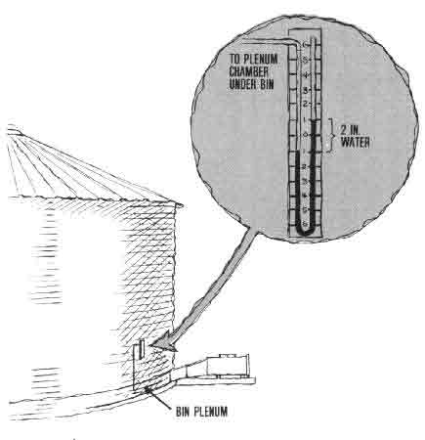

Figure 2. A simple manometer connected to a section of grain bin. To measure static pressure (non-moving, no-velocity air), the opening at the end of the manometer tube that extends into the bin plenum must be at a right angle to the moving air; the other end is open to the atmosphere. On a frame with a scale calibrated in inches, the tube is `U' shaped and partly filled with fluid (sometimes colored for easier reading). In this figure, the difference in the fluid level between the two columns of the `U' is 2 inches, meaning the fan is operating under 2 inches of static pressure (water column).
The easier the air moves through the grain, the lower the static pressure. Thus, as a grain bin is filled with the fan "on," air flow is restricted and the static pressure increases. Increasing the air flow rate for a given depth of grain will increase the static pressure rapidly.
This relationship of static pressure and grain depth is presented graphically in Figure 3. To use the graph, follow the 16-foot depth line from the bottom of the graph, projecting upward to intersect the 1 and 2 cfm/bu. curves. Project these intercepts across to the static pressure scale on the left side of the graph. You will read approximately 2.4 and 6.4 inches of water column static pressure.
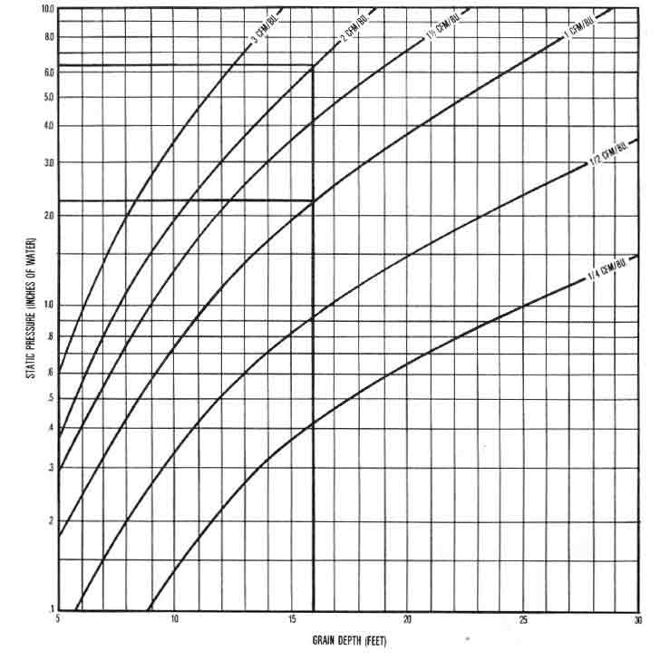

Figure 3. Grain depth vs. static pressure at selected air flow rates for bin drying shelled corn and soybeans.
As you see, static pressure nearly triples when the air flow doubles. Pressure values for other combinations of fill depths and air flow levels can be estimated similarly.

Static Pressure vs. Fan Type
Table 2 compares typical air performance data for a vane-axial fan and a centrifugal fan, each with a 10 hp motor. Air flow capabilities of the two types of fan differ significantly above and below the equal-performance point, which is about 4.0-4.5 inches of static pressure.

Table 2. Typical Fan Data for a 10-hp Vane Axial Fan and a 10-hp Centrifugal Fan.

Air flow at static pressures of--
Type of fan ------------------------------------------------------------------------------
fan diameter 1.0" 1.5" 2.0" 2.5" 3.0" 3.5" 4.0" 4.5" 5.0" 5.5" 6.0"
---------------------------------------------------------------------------------------------------
inches cubic feet per minute

Vane axial 28 19,000 18,100 17,000 16,200 14,900 13,800 12,700 -- 9,400 -- --
Centrifugal 24 13,200 __ 12,700 -- 12,100 -- 11,300 -- 9,000 -- 8,500
-----------------------------------------------------------------------------------------------------

Vane-axial fans (Figure 4a) supply more cfm per horsepower at static pressures below 4.0-4.5 inches of water than centrifugal units. For this reason, these fans are generally better adapted to shallow-depth bin drying systems, such as batch-in-bin and continuous-in-bin systems, and to deep bin drying up to 20-foot depths requiring 1 cfm/bu. air flow or less. They are generally lower in initial cost, but operate at a higher noise level than centrifugal fans.
Centrifugal fans (Figure 4b) supply more cfm per horsepower at static pressures above 4.0-4.5 inches of water than vane-axial fans. They are especially advantageous when the application requires relatively high air volumes through deep grain levels (12-20 feet), and where low noise is important.
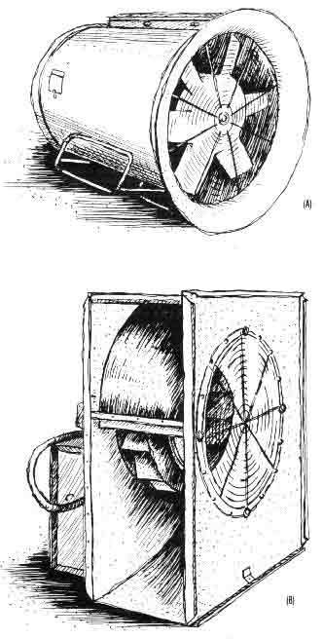

Figure 4. Basic fan types for bin drying/cooling. (a) The vane-axial type has a propeller and vanes, and is best for static pressures under 4.0-4.5 inches of water. (b) The centrifugal type generally supplies more cfm per horsepower at static pressures over 4.0-4.5 inches of water and is often used where low noise level is desired.

FAN PERFORMANCE DATA
The tables and charts in this publication can help you estimate fan performance for bin drying or cooling. The data, although based on shelled yellow-dent corn, are also generally applicable to soybeans. Fan performance is based on a packing factor of 1.5 times that of clean shelled corn and an installed fan efficiency typical of commercial fans.

Packing Factor
Packing factor is an index or ratio of the air flow resistance of a given grain depth to the resistance of the same grain when cleaned and piled in a loose fill. Loose fill occurs when grain is introduced into a bin at nearly zero velocity (without dropping), flowing into a cone-shaped pile. The descending grain then rolls or slides slowly down the coned grain surface.
In contrast, the grain in your bins usually has greater resistance to air flow than loose-fill grain. This is because it contains `fines,' is often dropped some distance onto the pile or is thrown by a distributor to the grain surface. As grain is distributed from above onto a surface of accumulated grain, the impact of the dropping, skipping kernels agitates the surface of the grain already in place. This agitation tends to orient the grain kernels into tightly-compacted positions, and causes fines to sift into the open spaces between kernels. The result is a "compacted fill."
The amount and the distribution of fines in grain for drying or aeration are very important. A high level of fines sharply increases the grain resistance to air flow. And the uneven distribution of fines prevents uniform air flow through various sections of the grain mass.
A packing factor is usually applied to grain in designing air flow systems in order to compensate for normal packed fill, fines deposit and air duct losses. A packing factor of 1.5 is a good design value for shelled corn and assumes a 50 percent increase in overall air flow resistance compared to loose fill.

Fan Efficiency
Fan efficiency for crop-drying and aeration fans will typically range from a high of 55-60 percent down to 40 percent. The installed efficiency depends on: (1) the quality of the fan and (2) the static pressure of the load in relation to the fan's performance curve. If the load very nearly matches the high performance range of the fan's output curve, the installed fan efficiency will be high. Conversely, if the fan output curve and load characteristics match poorly, the installed fan performance may be low.
The fan performance data in this publication are based on fan curves for each horsepower size, derived by averaging the data from a number of commercial fans. These fans, when applied correctly, will normally operate in an efficiency range of 50-60 percent.

Air Flow Guidelines
In selecting or evaluating fans for grain drying and bin cooling systems, the guidelines in Table 3 may be used.

Table 3. Recommended Air Flow Rates for Bin Cooling and Drying.

Rate max. and min. or Recommended
System grain moisture level air flow rate
------------------------------------------------------------------
Dryeration & bin cooling Minimum 0.5 cfm/bu.
Good design 0.75 cfm/bu.
Maximum 1.0 cfm/bu.
------------------------------------------------------------------
Deep bed bin drying*
Corn 20-22% moisture 1.0 cfm/bu.
22-24% moisture 2.0 cfm/bu.
24-26% moisture 3.0 cfm/bu.
----------------------------------------------------------------
Soybeans 17% moisture 1.0 cfm/bu.
19% moisture 2.0 cfm/bu.
21% moisture 3.0 cfm/bu.
-------------------------------------------------------------------
* 12-16 feet deep preferred, 20 feet maximum recommended.
The air flow rates listed for dryeration and bin cooling are adequate. But the question is, how fast do you wish to cool the grain? At 0.5 cfm/bu. air flow rate, the cooling time will be roughly 10-15 hours of fan operation. A 1.0 cfm/bu. rate will cut this time roughly in half-to 6-8 hours.
Dryeration air flow rates should not exceed the maximum recommended design level of 1.0 cfm/bu. to avoid exhausting the warm air from the corn before it can pick up a full load of moisture. The air flow rate is not critical during bin cooling if there is no heat-soak or tempering period prior to cooling. But grain that is bin-cooled immediately (with the higher air flow rates used for bin drying) could suffer a reduction in quality.
The air flow rates listed for corn and soybean drying are only for deep-bed bin drying systems. Partial-fill systems using batch-in-bin or continuous-in-bin methods run at much higher air flow and drying rates.

USING THE BIN DRYING PERFORMANCE TABLES
This publication provides air flow rate performance tables for bin drying with selected tan sizes and grain depths in bins 14, 18, 21, 24, 27, 30, 33, 36, 40, 42 and 48 feet in diameter (Tables 6-16). For purposes of illustration here, Table 4 (repeated later as Table 11) presents the performance data for a 30-foot bin.
In the table, grain depth and corresponding bushel volume are shown across the top of the columns, while fan horsepower is arranged down the left-most column. The data in the body of the table are air flow rates in cfm/bu. All grain fills are assumed to be level (not peaked).
Now, let's apply this example table to several typical, practical situations:
How do I choose fan horsepower for an existing or new bin?
Assume that you wish to dry 16 feet of shelled corn in a 30-foot diameter bin at a 1.5 cfm/bu. air flow rate. Enter Table 4 at the 16-foot depth heading at the top of the chart. Follow down the air flow values until you find one of at least 1.5 cfm/bu. (1.55 cfm/bu.). Then move left to the first column and read the required horsepower (15).

Table 4. Air Flow Rates at Various Fan Sizes and Grain Depths for Drying Shelled Corn and Soybeans in a 30-Foot Diameter Bin (Average commercial fan performance and 1.5 packing factor).*

Air flow rate needed for a grain depth (and corresponding bushel volume) of--
----------------------------------------------------------------------------------------
Fan 2 ft. 4 ft. 6 ft. 8 ft. 10 ft. 12 ft. 14 ft. 16 ft. 18 ft. 20 ft. 22 ft. 24 ft.
hp (1131) (2262) (3393) (4524) (5655) (6786) (7917) (9048) (10179) (11310) (12441) (13572)
--------------------------------------------------------------------------------------------------
cfm/bushel **

0.33 1.38 .68 .45 .34 .27 .22 .19 .16 .14 .13 .12 .11
0.5 1.80 .89 .59 .44 .35 .29 .25 .21 .19 .17 .15 .14
0.75 1.94 .97 .64 .48 .38 .32 .27 .24 .21 .19 .17 .16

1.0 2.58 1.29 .85 .64 .51 .42 .36 .31 .28 .25 .22 .20
1.5 3.75 1.86 1.23 .92 .73 .60 .51 .44 .39 .35 .31 .28
2.0 4.58 2.25 1.48 1.09 .86 .70 .60 .51 .45 .40 .36 .32

3.0 5.83 2.89 1.90 1.41 1.11 .92 .77 .66 .58 .51 .45 .41
4.0 7.31 3.62 2.37 1.74 1.36 1.10 .92 .78 .68 .59 .53 .47
5.0 9.43 4.63 3.00 2.18 1.69 1.36 1.13 .96 .83 .72 .64 .57

7.5 11.39 5.54 3.57 2.58 1.99 1.60 1.33 1.12 .97 .85 .75 .66
10.0 13.51 6.58 4.23 3.02 2.32 1.86 1.53 1.28 1.10 .96 .84 .75
12.5 15.43 7.37 4.71 3.36 2.56 2.04 1.67 1.39 1.19 1.04 .92 .81

15.0 19.76 9.18 5.64 3.92 2.93 2.30 1.86 1.55 1.32 1.14 .99 .88
20.0 22.46 10.20 6.25 4.30 3.18 2.46 1.99 1.65 1.39 1.20 1.05 .93
25.0 25.93 11.31 6.77 4.66 3.44 2.65 2.12 1.76 1.49 1.27 1.10 .97
----------------
30.0 29.53 12.66 7.45 5.02 3.68 2.86 2.28 1.87 1.57 1.34 | 1.18 1.06
------------------------
40.0 33.00 13.78 7.97 5.33 3.89 2.99 2.38 | 2.04 1.63 1.56 1.39 1.25
50.0 39.39 15.57 8.92 5.87 4.26 3.27 2.58 | 2.21 1.92 1.70 1.52 1.36
--------------------------------------------------------------------------------------------------
* Fan performance based on an average of a number of commercial
fans for each hp. Packing factor assumes 1.5 x Shedd's data for
clean, loose-filled grain (10.0). See reference section for source
details.

**Cfm values below stepped line are centrifugal fans; above line
are van axial designs. Change normally occurs between 4 and 5 inches
static pressure.

How do I determine the air flow with an existing fan and bin combination?
Assume that you have a 10-hp fan and a 12-foot grain depth. Enter the 10-hp row on the left column of Table 4. Follow this row to the right until you come to the column headed by a 12-foot depth, and read the estimated fan air delivery (1.86 cfm/bu.).
Should I have a vane-axial or centrifugal fan for the above bin reference?
Referring to Figure 3, enter the 12-foot grain depth line (along the bottom of the graph), and follow it upward till it intersects with an air flow curve that would correspond to 1.86 cfm/bu. (estimated point between the 1.5 and 2.0 cfm/bu. curves). Follow the intersect point horizontally to the left margin, and read the static pressure (2.8 inches).
You should choose a vane-axial fan because the static pressure is below 4.0-4.5 inches of water. The fan should deliver at least 12,622 cfm at 2.8 inches static pressure (1.86 cfm x 6786 bu., as listed for a 12-foot depth in Table 4).
How will a change in grain depth affect the air delivery of my existing fan?
Again assuming a 10-hp fan and a 12-foot grain depth in a 30-foot diameter bin, let's compare the total air flow with that required for grain depths of 6 feet and 16 feet. Table 4 shows the following values for a 10 hp fan:
Grain depth 6 ft. 12 ft. 16 ft.
Grain volume 3,393 bu. 6,786 bu. 9,048 bu.
Est. air flow 4.23 cfm/bu 1.86 cfm/bu. 1.28 cfm/bu.
Total air flow 14,352 cfm 12,622 cfm 11,581 cfm
The total air flow values are simply grain volume multiplied by cfm/bu. Note that total air flow increases as the grain depth and volume decrease. In this way, air flow per bushel and-drying potential are sharply increased.
What effect would doubling horsepower have on air flow?
Looking at the same 6-, 12- and 16-foot grain depth columns in Table 4, we see that doubling the fan horsepower from 10 to 20 hp increases the air delivery-- both per bushel and total--by only about one-third. Thus, roughly two-thirds of the horsepower (energy) is expended with no increase in air flow.
Grain depth 6 ft. 12 ft. 16 ft.
Grain volume 3,393 bu. 6,786 bu. 9,048 bu.
10-hp fan 4.23 cfm/bu. 1.86 cfm/bu. 1.28 cfm/bu.
20-hp fan 6.25 cfm/bu. 2.46 cfm/bu. 1.65 cfm/bu.
What, then, happened to this two-thirds of the additional 10 horsepower? It was converted into heat, because of the "churning" of the air that the fan produced as it worked to force the increased air flow through "the same size hole" (i.e., the bin diameter which did not change). Although this loss reflects a loss in air flow efficiency, it is not a total loss, since the added heat is useful in drying grain.
Performance data for two fans having the same horsepower and air flow capabilities can be added to estimate total system performance. Two smaller fans may actually deliver slightly more or less air flow than a larger fan of the same total horsepower, depending on the combined air flow characteristics of the two smaller units compared with the larger one. But the difference will usually be small.

DRYERATION AND BIN COOLING PERFORMANCE TABLE AND GUIDELINES
Since air flow rates for dryeration and bin cooling are below that required for bin drying, greater depths of grain (up to 50 feet) may be processed when air flow rates are 0.5 cfm/bu. Also, cooling fronts traverse the grain bed roughly 50 times faster than drying fronts. Thus, whereas grain spoilage is the limiting criterion for any drying bed over 20 feet deep (involving more than a point or two of moisture removal), the upper limits of cooling depths are determined largely by the cost of owning and operating the horsepower required to push air through the grain mass.

Using the Performance Table
Table 5 presents data to help estimate the horsepower required for dryeration and bin cooling structures. The data apply to both hopper- and flat-bottom storages. The critical consideration is to make sure that the air supply system is adequate--i.e., has sufficient perforated floor area, supply duct cross-sectional area and fan horsepower.
All static pressure values for a given air flow rate are the same for each corresponding grain depth, regardless of bin size. For instance, the static pressure for the 0.5 cfm/bu. air flow rate is 4.4 inches of water for a 30-foot grain depth at all bin diameters. The reason is that the air flow per bushel and grain depth are the same in all cases.
Doubling a bin's floor area doubles its bushel capacity for the same grain depth. But if twice the number of bushels is to be aerated at the same 0.5 cfm/bu., the total amount of air flow must also double. However, the velocity of air flowing through any one column of grain will be constant, so static pressure will also be constant.
In contrast, increasing the air flow rate from 0.5 to 0.75 cfm/bu. in the 30-foot diameter bin for a 30-foot grain depth, for instance, increases the static pressure from 4.4 to 7.5 inches. Pushing more air through the "same size hole" sharply increases air velocity, resulting in greater air drag and resistance. In this case, a centrifugal rather than a vane-axial fan should be used.
For example, consider a 24-foot diameter bin, filled to a 20-foot level. The holding capacity is shown in Table 5 to be 7238 bushels--a big day's run for a large grain farm. Reading across the 24-foot diameter, 20-foot grain depth line, note that 2.3 hp is required to deliver 0.5 cfm/bu. Doubling the air flow rate to 1.0 cfm/bu. requires 10.2 hp-almost a five-fold increase!
The amount of perforated surface area needed to deliver the required air into the grain is shown in the three righthand "duct area" columns of Table 5. If the perforated area shown for your cooling bin is too small, increase it to bring the air distribution system into the recommended range. If this is not possible, shift to a lower air flow rate or lower grain depth to reduce air flow to the capacity of the perforated surface area.

Estimating Required Horsepower and Surface Area
If the size of your cooling bin is not listed in Table 5, you can estimate the horsepower and perforated surface areas as follows:
1. Calculate the holding capacity of your bin for the grain depth desired, using a factor of 1.25 cu.ft./bu.
2. Select the bin diameter from Table 5 closest in bushel capacity for the same storage height, but larger than your unit.
3. Divide the bushel capacity of your bin by that of the bin in Table 5. (Remember, the bushel capacities of the two bins must be for the same fill height.) The result is the ratio of your bin size to the slightly larger unit of Table 5.
4. Read the horsepower and perforated surface area values for the larger bin from Table 5.
5. Multiply these larger bin horsepower and surface area values by the ratio in step 3 to find the values for your bin. The only restriction is that your bin must have a uniform cross-sectional area for its full height.

Table 5. Design Requirements for Air Flow Rates of 1/2, 3/4 and 1 Cfm/Bu. in Dryeration and Bin Cooling of Shelled Corn for Various Bin Diameters and Grain Depths.*

Air volume Static pressure Fan power Duct area
Bin Grain Grain ------------- ------------- ------------- ----------
dia. depth volume 1/2 3/4 1 1/2 3/4 1 1/2 3/4 1 1/2 3/4 1
--------------------------------------------------------------------------------------------------
ft. ft. bu. cu.ft./min. in. water sq.~. sq.in.

14 2.5 308 154 231 308 0.52 0.53 0.54 0.03 0.04 0.05 5 8 10
5.0 616 308 462 616 0.57 0.62 0.67 0.06 0.09 0.13 10 15 21
7.5 924 462 693 924 0.67 0.77 0.89 0.10 0.17 0.26 15 23 31
10.0 1232 616 924 1232 0.83 1.03 1.28 0.16 0.30 0.50 21 31 41
12.5 1539 770 1155 1539 1.03 1.36 1.80 0.25 0.49 0.87 26 38 51
15.0 1847 924 1385 1847 1.31 1.85 2.17 0.38 0.81 1.26 31 46 62
17.5 2155 1078 1616 2155 1.60 2.34 3.65 0.54 1.19 2.48 36 54 72
20.0 2463 1232 1847 2463 2.06 3.08 4.40 0.80 1.79 3.41 41 62 82
30.0 3695 1847 2771 3695 4.40 7.50 11.30 2.56 6.54 13.14 62 92 123
40.0 4926 2463 3695 4926 8.30 14.90 **** 6.43 17.32 **** 82 123 ***
50.0 6158 3079 4618 6158 14.00 **** **** 13.56 **** **** 103 *** ***

18 2.5 509 254 382 509 0.52 0.53 0.54 0.04 0.06 0.09 8 13 17
5.0 1018 509 763 1018 0.57 0.62 0.67 0.09 0.15 0.21 17 25 34
7.5 1527 763 1145 1527 0.67 0.77 0.89 0.16 0.28 0.43 25 38 51
10.0 2036 1018 1527 2036 0.83 1.03 1.28 0.27 0.49 0.82 34 51 68
12.5 2545 1272 1909 2545 1.03 1.36 1.80 0.41 0.82 1.44 42 64 85
15.0 3054 1527 2290 3054 1.31 1.85 2.17 0.63 1.33 2.09 51 76 102
17.5 3563 1781 2672 3563 1.60 2.34 3.65 0.90 1.97 4.09 59 89 119
20.0 4072 2036 3054 4072 2.06 3.08 4.40 1.32 2.96 5.64 68 102 136
30.0 6107 3054 4580 6107 4.40 7.50 11.30 4.23 10.81 21.72 102 153 204
40.0 8143 4072 6107 8143 8.30 14.90 **** 10.63 28.63 **** 136 204 ***
50.0 10179 5089 7634 10179 14.00 **** **** 22.42 **** **** 170 *** ***

21 2.5 693 346 520 693 0.52 0.53 0.54 0.06 0.09 0.12 12 17 23
5.0 1385 693 1039 1385 0.57 0.62 0.67 0.12 0.20 0.29 23 35 46
7.5 2078 1039 1559 2078 0.67 0.77 0.89 0.22 0.38 0.58 35 52 69
10.0 2771 1385 2078 2771 0.83 1.03 1.28 0.36 0.67 1.12 46 69 92
12.5 3464 1732 2598 3464 1.03 1.36 1.80 0.56 1.11 1.96 58 87 115
15.0 4156 2078 3117 4156 1.31 1.85 2.17 0.86 1.81 2.84 69 104 139
17.5 4849 2425 3637 4849 1.60 2.34 3.65 1.22 2.68 5.57 81 121 162
20.0 5542 2771 4156 5542 2.06 3.08 4.40 1.80 4.03 7.67 92 139 185
30.0 8313 4156 6235 8313 4.40 7.50 11.30 5.75 14.71 29.56 139 208 277
40.0 11084 5542 8313 11084 8.30 14.90 **** 14.47 38.97 **** 185 277 ***
50.0 13855 6927 10391 13855 14.00 **** **** 30.52 **** **** 231 *** ***

24 2.5 905 452 679 905 0.52 0.53 0.54 0.07 0.11 0.15 15 23 30
5.0 1810 905 1357 1810 0.57 0.62 0.67 0.16 0.26 0.38 30 45 60
7.5 2714 1357 2036 2714 0.67 0.77 0.89 0.29 0.49 0.76 45 68 90
10.0 3619 1810 2714 3619 0.83 1.03 1.28 0.47 0.88 1.46 60 90 121
12.5 4524 2262 3393 4524 1.03 1.36 1.80 0.73 1.45 2.56 75 113 151
15.0 5429 2714 4072 5429 1.31 1.85 2.17 1.12 2.37 3.71 90 136 181
17.5 6333 3167 4750 6333 1.60 2.34 3.65 1.59 3.50 7.27 106 158 211
20.0 7238 3619 5429 7238 2.06 3.08 4.40 2.35 5.26 10.02 121 181 241
30.0 10857 5429 8143 10857 4.40 7.50 11.30 7.52 19.22 38.61 181 271 362
40.0 14477 7238 10857 14477 8.30 14.90 **** 18.90 50.90 **** 241 362 ***
50.0 18096 9048 13572 18096 14.00 **** **** 39.86 **** **** 302 *** ***

27 2.5 1145 573 859 1145 0.52 0.53 0.54 0.09 0.14 0.19 19 29 38
5.0 2290 1145 1718 2290 0.57 0.62 0.67 0.21 0.34 0.48 38 57 76
7.5 3435 1718 2577 3435 0.67 0.77 0.89 0.36 0.62 0.96 57 86 115
10.0 4580 2290 3435 4580 0.83 1.03 1.28 0.60 1.11 1.84 76 115 153
12.5 5726 2863 4294 5726 1.03 1.36 1.80 0.93 1.84 3.24 95 143 191
15.0 6871 3435 5153 6871 1.31 1.85 2.17 1.42 3.00 4.69 115 172 229
17.5 8016 4008 6012 8016 1.60 2.34 3.65 2.02 4.43 9.21 134 200 267
20.0 9161 4580 6871 9161 2.06 3.08 4.40 2.97 6.66 12.68 153 229 305
30.0 13741 6871 10306 13741 4.40 7.50 11.30 9.51 24.32 48.86 229 344 458
40.0 18322 9161 13741 18322 8.30 14.90 **** 23.93 64.43 **** 305 458 ***
50.0 22902 11451 17177 22902 14.00 **** **** 50.45 **** **** 382 *** ***

30 2.5 1414 707 1060 1414 0.52 0.53 0.54 0.12 0.18 0.24 24 35 47
5.0 2827 1414 2121 2827 0.57 0.62 0.67 0.25 0.41 0.60 47 71 94
7.5 4241 2121 3181 4241 0.67 0.77 0.89 0.45 0.77 1.19 71 106 141
10.0 5655 2827 4241 5655 0.83 1.03 1.28 0.74 1.37 2.28 94 141 188
12.5 7069 3534 5301 7069 1.03 1.36 1.80 1.15 2.27 4.00 118 177 236
15.0 8482 4241 6362 8482 1.31 1.85 2.17 1.75 3.70 5.79 141 212 283
17.5 9896 4948 7422 9896 1.60 2.34 3.65 2.49 5.46 11.37 165 247 330
20.0 11310 5655 8482 11310 2.06 3.08 4.40 3.67 8.22 15.66 188 283 377
30.0 16965 8482 12724 16965 4.40 7.50 11.30 11.74 30.03 60.32 283 424 565
40.0 22620 11310 16965 22620 8.30 14.90 **** 29.54 79.54 **** 377 565 ***
50.0 28274 14137 21206 28274 14.00 **** **** 62.28 **** **** 471 *** ***

33 2.5 1711 855 1283 1711 0.52 0.53 0.54 0.14 0.21 0.29 29 43 57
5.0 3421 1711 2566 3421 0.57 0.62 0.67 0.31 0.50 0.72 57 86 114
7.5 5132 2566 3849 5132 0.67 0.77 0.89 0.54 0.93 1.44 86 128 171
10.0 6842 3421 5132 6842 0.83 1.03 1.28 0.89 1.66 2.76 114 171 228
12.5 8553 4277 6415 8553 1.03 1.36 1.80 1.39 2.75 4.84 143 214 285
15.0 10264 5132 7698 10264 1.31 1.85 2.17 2.12 4.48 7.01 171 257 342
17.5 11974 5987 8981 11974 1.60 2.34 3.65 3.01 6.61 13.75 200 299 399
20.0 13685 6842 10264 13685 2.06 3.08 4.40 4.44 9.95 18.95 228 342 456
30.0 20527 10264 15395 20527 4.40 7.50 11.30 14.21 36.33 72.99 342 513 684
40.0 27370 13685 20527 27370 8.30 14.90 **** 35.74 96.24 **** 456 684 ***
50.0 34212 17106 25659 34212 14.00 **** **** 75.36 **** **** 570 *** ***

36 2.5 2036 1018 1527 2036 0.52 0.53 0.54 0.17 0.25 0.35 34 51 68
5.0 4072 2036 3054 4072 0.57 0.62 0.67 0.37 0.60 0.86 68 102 136
7.5 6107 3054 4580 6107 0.67 0.77 0.89 0.64 1.11 1.71 102 153 204
10.0 8143 4072 6107 8143 0.83 1.03 1.28 1.06 1.98 3.28 136 204 271
12.5 10179 5089 7634 10179 1.03 1.36 1.80 1.65 3.27 5.77 170 254 339
15.0 12215 6107 9161 12215 1.31 1.85 2.17 2.52 5.33 8.34 204 305 407
17.5 14250 7125 10688 14250 1.60 2.34 3.65 3.59 7.87 16.37 238 356 475
20.0 16286 8143 12215 16286 2.06 3.08 4.40 5.28 11.84 22.55 271 407 543
30.0 24429 12215 18322 24429 4.40 7.50 11.30 16.91 43.24 86.86 407 611 814
40.0 32572 16286 24429 32572 8.30 14.90 **** 42.53 **8* **** 543 *** ***

40 2.5 2513 1257 1885 2513 0.52 0.53 0.54 0.21 0.31 0.43 42 63 84
5.0 5027 2513 3770 5027 0.57 0.62 0.67 0.45 0.74 1.06 84 126 168
7.5 7540 3770 5655 7540 0.67 0.77 0.89 0.79 1.37 2.11 126 188 251
10.0 10053 5027 7540 10053 0.83 1.03 1.28 1.31 2.44 4.05 168 251 335
12.5 12566 6283 9425 12566 1.03 1.36 1.80 2.04 4.03 7.12 209 314 419
15.0 15080 7540 11310 15080 1.31 1.85 2.17 3.11 6.58 10.30 251 377 503
17.5 17593 8796 13195 17593 1.60 2.34 3.65 4.43 9.72 20.21 293 440 586
20.0 20106 10053 15080 20106 2.06 3.08 4.40 6.52 14.61 27.84 335 503 670
30.0 30159 15080 22620 30159 4.40 7.50 11.30 20.88 53.38 **** 503 754 ***
40.0 40213 20106 30159 40213 8.30 14.90 **** 52.51 **** **** 670 *** ***

42 2.5 2771 1385 2078 2771 0.52 0.53 0.54 0.23 0.35 0.47 46 69 92
5.0 5542 2771 4156 5542 0.57 0.62 0.67 0.50 0.81 1.17 92 139 185
7.5 8313 4156 6235 8313 0.67 0.77 0.89 0.88 1.51 2.33 139 208 277
10.0 11084 5542 8313 11084 0.83 1.03 1.28 1.45 2.69 4.46 185 277 369
12.5 13855 6927 10391 13855 1.03 1.36 1.80 2.25 4.45 7.85 231 346 462
15.0 16625 8313 12469 16625 1.31 1.85 2.17 3.43 7.26 11.35 277 416 554
17.5 19396 9698 14547 19396 1.60 2.34 3.65 4.88 10.71 22.28 323 485 647
20.0 22167 11084 16625 22167 2.06 3.08 4.40 7.18 16.11 30.69 369 554 739
30.0 33251 16625 24938 33251 4.40 7.50 11.30 23.02 58.85 **** 554 831 ***
40.0 44334 22167 33251 44334 8.30 14.90 **** 57.89 **** **** 739 *** ***

48 2.5 3619 1810 2714 3619 0.52 0.53 0.54 0.30 0.45 0.61 60 90 121
5.0 7238 3619 5429 7238 0.57 0.62 0.67 0.65 1.06 1.53 121 181 241
7.5 10857 5429 8143 10857 0.67 0.77 0.89 1.14 1.97 3.04 181 271 362
10.0 14477 7238 10857 14477 0.83 1.03 1.28 1.89 3.52 5.83 241 362 483
12.5 18096 9048 13572 18096 1.03 1.36 1.80 2.93 5.81 10.25 302 452 603
15.0 21715 10857 16286 21715 1.31 1.85 2.17 4.48 9.48 14.83 362 543 724
17.5 25334 12667 19000 25334 1.60 2.34 3.65 6.38 13.99 29.10 422 633 844
20.0 28953 14477 21715 28953 2.06 3.08 4.40 9.38 21.05 40.09 483 724 965
30.0 43430 21715 32572 43430 4.40 7.50 11.30 30.06 76.87 **** 724 *** ***
40.0 57906 28953 43430 57906 8.30 14.90 **** 75.62 **** **** 965 *** ***
----------------------------------------------------------------------------------------------------
* Airflow resistance is based on ASAE standard data for clean shelled
corn, increased 50 percent for fire material and compaction plus 0.5
inches of water column allowance for duct and entrance loss. Fan
horsepower is calculated on the basis of 50 percent "installed" fan
efficiency.

PLOTTING AIR FLOW SYSTEM PERFORMANCE
Figure 5 relates fan performance, grain depth and air flow rate simultaneously for a particular fan. The instructions for plotting the performance curve for your present or proposed fan are given with the graph.
The cfm-vs.-static-pressure data for the two 10-hp fans listed in Table 2 have been converted in Figure 5 into cfm/sq.ft. values for each static pressure level, assuming a 30-foot diameter bin. These values have been plotted in Figure 5 for both fans.
The two fan curves cross at about 4.6 inches of static pressure--the equal performance point--forming the basis for selecting fan type. The intersection of either fan curve with the grain depth and air flow rate curve specifies the system performance at that combination.
Fan curves for other sized units may be plotted similarly using the worksheet. Use thin paper or clear plastic overlay sheets to protect the original and reduce confusion.

FACTORS AFFECTING FAN PERFORMANCE

Drying Capacity vs. Grain Depth
It should be apparent from the previous examples and from Tables 6-16 that grain depth has a marked influence on drying system performance and, therefore, on drying capacity. If you are having drying capacity or grain spoilage problems in bin drying systems, reduce the grain depth! This reduces the static pressure and allows the fan to deliver more total air to a smaller quantity of grain. The higher air volume will then permit you to use higher temperatures (for the same limits on moisture), thereby further increasing your drying rate.
Many farmers don't like to batch dry in a bin at shallow depths, because their handling methods are not sized or convenient for frequent transfers of grain. However, in a given period of time and with the same equipment, you can dry roughly twice as much grain doing it in 4-foot deep batches as you could in 8-foot batches. Rather than assuming the drying system is at fault, maybe you should re-evaluate your grain transfer system to increase drying capacity.

Fines and Air Flow Uniformity
Distribution of fine material in grain influences the rate and distribution of air flow. Paradoxically, a perfect distribution of fines causes the highest air flow resistance, because particles of fine material are in every open space between all adjacent kernels throughout the bin. Such perfect distribution may result in as much as a 200-400 percent increase in air flow resistance, compared with grain distributed as loose fill. This does not mean, though, that the fan air volume will be halved or quartered.
We noted earlier from Table 2 that fan delivery drops off as air flow resistance (static pressure) increases, but not on a one-to-one basis. Most high-pressure grain drying fans do not drop off rapidly in air volume capacity until the static pressure becomes high enough that the fan begins to "stall out."
Non-uniform air distribution, caused by uneven deposit of fines, means non-uniform drying or cooling. The fan must operate longer to accomplish drying or cooling in high resistance areas--requiring extra energy, time and cost. Bin drying and cooling performance is very dependent on air flow. The management and distribution of fine materials should not be taken lightly.

Unusual Fan Horsepower Ratings
Manufacturers' horsepower listings on grain drying fans are sometimes confusing. For example, some fans show a dual rating, such as "10.0-12.5 hp." This stems from three practices.
First, some electric power suppliers restrict motor size on their lines to a maximum 7.5 or 10 hp, while others permit installing a dual-rated motor, as long as the lower rating falls within the prescribed restriction.
Second, axial-flow crop drying fans are "air-over" motor designs that generally supply added freedom in motor rating because of the increased cooling provided by the flowing air.
Third, fan horsepower depends on the pounds of air a fan moves per unit of time at a specified temperature. A fan moves the same volume of air in cold weather as in warm weather. But since cold air is denser than warm air (weighs more per cubic foot), the fan pumps more pounds of air in winter, requiring more power than in summer.
Thus, a fan may demand only 10 hp under one set of operating conditions early in the season, but may increase its demand to 12.5 hp as air becomes colder and drying circumstances change.

Figure 5. Fan/air system performance chart and example.
The two fan curves in the chart were developed from fan performance data similar to that supplied by all fan manufacturers. You may plot similar curves for your own specific fan(s) characteristics by following these instructions:
1. Calculate the floor area of the desired bin.
2. Find air delivery vs. static pressure from the fan manufacturer's literature.
3. Divide air delivery at each static pressure by the bin floor area.
4. Plot on the chart the resulting cfm/sq.ft. value for each static pressure quoted, and draw a curve through these points.
5. Read fan performance for selected air flow levels and grain depths from the intercepts with the depth/air flow curves.
(Suggestion: Plot fan curves on clear overlay sheets to preserve the master chart for repeated use.)
Example: Fan horsepower = 10 hp
Floor area of 30 foot diameter bin = (30)²(3.1416)/4
= (900)(3.1416)/4
= 706.86 sq ft

Static pressure (inches water)
-------------------------------------------------------------------------------------------------------------------------------------------
1.0 1.5 2.0 2.5 3.0 3.5 4.0 4.5 5.0 5.5 6.0
-------------------------------------------------------------------------------------------------------------------------------------------
cfm cfm/ cfm cfm/ cfm cfm/ cfm cfm/ cfm cfm/ cfm cfm/ cfm cfm/ cfm cfm/ cfm cfm/ cfm cfm/ cfm cfm/
sq.ft. sq.ft sq.ft sq.ft. sq.ft. sq.ft. sq.ft. sq.ft. sq.ft. sq.ft. sq.ft.
---------------------------------------------------------------------------------------------------------------------------------------------------
Vane- 19,400 27.4 18,400 26.0 17,300 24.5 16,300 23.1 15,100 21.4 14,000 19.8 12,800 18.1 - - 9,500 13.4 - - - -
axial
--------------------------------------------------------------------------------------------------------------------------------------------------
Centri-
fugal 13,600 19.2 - 13,000 18.4 - 12,000 17.0 - 11,000 15.6 - 10,000 14.1 - 8,500 12.0
---------------------------------------------------------------------------------------------------------------------------------------------------

Your Calculations: Fan Horsepower =
Floor area of _____ - foot diameter bin =

Static pressure (inches water)
-------------------------------------------------------------------------------------------------------------------------------------------
1.0 1.5 2.0 2.5 3.0 3.5 4.0 4.5 5.0 5.5 6.0
-------------------------------------------------------------------------------------------------------------------------------------------
cfm cfm/ cfm cfm/ cfm cfm/ cfm cfm/ cfm cfm/ cfm cfm/ cfm cfm/ cfm cfm/ cfm cfm/ cfm cfm/ cfm cfm/
sq.ft. sq.ft sq.ft sq.ft. sq.ft. sq.ft. sq.ft. sq.ft. sq.ft. sq.ft. sq.ft.
---------------------------------------------------------------------------------------------------------------------------------------------------
Vane-
axial
--------------------------------------------------------------------------------------------------------------------------------------------------
Centri-
fugal
---------------------------------------------------------------------------------------------------------------------------------------------------

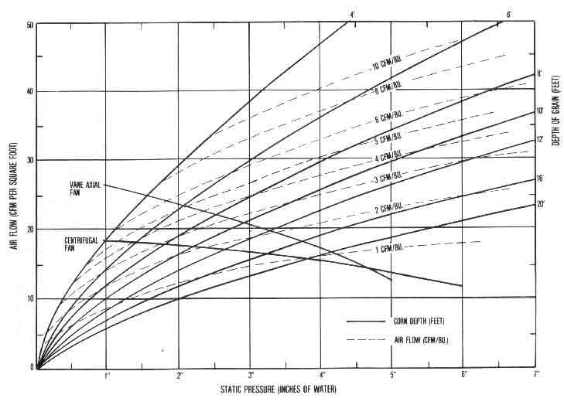

Bin Drying Air Flow Rate Performance Tables

Table 6. Air Flow Rates at Various Fan Sizes and Grain Depths for Drying Shelled Corn and Soybeans In a 14-Foot Diameter Bin (Average commercial fan performance and 1.5 packing factor) .*

Air flow rate needed for a grain depth (and corresponding bushel volume) of--
------------------------------------------------------------------------------------
Fan 2 ft. 4 ft. 6 ft. 8 ft. 10 ft. 12 ft. 14 ft. 16 ft. 18 ft. 20 ft. 22 ft. 24 ft.
hp (246) (493) (739) (985) (1232) (1478) (1724) (1970) (2217) (2463) (2709) (2956)
-----------------------------------------------------------------------------------------------
cfm/bushel**
0.33 6.09 2.92 1.87 1.34 1.03 .83 .68 .57 .49 .42 .37 .33
0.5 7.95 3.81 2.36 1.65 1.24 .97 .78 .64 .54 .46 .40 .35
0.75 8.75 4.24 2.65 1.88 1.39 1.08 .86 .71 .60 .52 .45 .39

1.0 11.59 5.46 3.39 2.36 1.76 1.36 1.08 .87 .73 .61 .53 .46
1.5 16.18 7.20 4.29 2.94 2.17 1.68 1.35 1.12 .94 .81 .70 .61
2.0 18.66 8.26 5.02 3.42 2.52 1.95 1.57 1.30 1.09 .93 .81 .71
----------------------------
3.0 23.68 10.17 5.99 4.02 2.93 2.25 1.79 1.47 | 1.26 1.10 .97 .87
4.0 27.43 11.31 6.51 4.34 3.13 2.39 1.89 1.54 | 1.29 1.11 .98 .88
----------------------------|
5.0 32.50 13.03 7.44 4.89 | 3.53 2.74 2.21 1.84 1.56 1.34 1.18 1.04
-------------
7.5 36.85 14.47 | 8.45 5.79 4.25 3.29 2.64 2.18 1.83 1.59 1.40 1.24
------
10.0 41.17 | 16.97 9.87 6.66 4.88 3.77 3.02 2.51 2.13 1.84 1.61 1.42
12.5 44.25 | 17.84 10.39 7.03 5.18 4.03 3.24 2.70 2.30 1.99 1.74 1.54
|
15.0 47.66 | 18.41 10.90 7.40 5.46 4.27 3.47 2.89 2.45 2.13 1.88 1.67
------------
20.0 50.03 20.81 12.08 8.21 6.05 4.70 3.81 3.17 2.69 2.32 2.04 1.82
25.0 52.57 21.96 12.95 8.79 6.48 5.12 4.19 3.51 3.00 2.61 2.29 2.03

30.0 57.18 23.83 13.94 9.52 7.08 5.55 4.51 3.77 3.21 2.77 2.43 2.16
40.0 66.06 26.58 15.51 10.61 7.85 6.10 4.95 4.13 3.53 3.08 2.70 2.39
50.0 72.49 29.09 16.86 11.46 8.46 6.61 5.37 4.49 3.83 3.31 2.89 2.55
--------------------------------------------------------------------------------------------
*and ** See footnotes accompanying Table 4.

Table 7. Air Flow Rates at Various Fan Sizes and Grain Depths for Drying Shelled Corn and Soybeans in a 18-Foot Diameter Bin (Average commercial fan performance and 1.5 packing factor).*

Air flow rate needed for a grain depth (and corresponding bushel volume) of--
------------------------------------------------------------------------------------
Fan 2 ft. 4 ft. 6 ft. 8 ft. 10 ft. 12 ft. 14 ft. 16 ft. 18 ft. 20 ft. 22 ft. 24 ft.
hp (407) (814) (1221) (1629) (2036) (2443) (2850) (3257) (3664) (4072) (4479) (4886)
-----------------------------------------------------------------------------------------------
cfm/bushel**

0.33 3.76 1.84 1.20 .88 .69 .56 .47 .40 .35 .31 .27 .25
0.5 4.90 2.40 1.56 1.15 .88 .71 .59 .50 .43 .37 .33 .29
0.75 5.34 2.64 1.74 1.27 .98 .79 .66 .56 .48 .42 .36 .32

1.0 7.10 3.51 2.27 1.65 1.28 1.02 .84 .70 .60 .52 .45 .40
1.5 10.23 4.93 3.15 2.22 1.68 1.33 1.08 .90 .76 .65 .57 .50
2.0 12.11 5.70 3.58 2.54 1.94 1.55 1.27 1.07 .91 .78 .68 .60

3.0 15.62 7.28 4.49 3.14 2.37 1.87 1.51 1.26 1.07 .92 .80 .71
4.0 19.20 8.54 5.13 3.52 2.61 2.03 1.64 1.36 1.15 .99 .86 .75
--------------
5.0 23.53 10.26 6.06 4.09 3.03 2.34 1.87 1.54 1.29 1.10 | .97 .86
-------------------------------------
7.5 27.61 11.80 6.89 4.63 3.37 | 2.63 2.16 1.81 1.54 1.33 1.16 1.03
-------------
10.0 31.92 13.30 7.74 | 5.40 4.04 3.15 2.55 2.11 1.79 1.54 1.34 1.18
12.5 34.96 14.34 8.32 | 5.73 4.26 3.33 2.70 2.24 1.90 1.64 1.43 1.27
|
15.0 39.44 15.54 8.93 | 5.91 4.41 3.48 2.84 2.37 2.01 1.73 1.52 1.34
------
20.0 42.19 16.36 | 9.63 6.74 5.01 3.90 3.17 2.64 2.25 1.94 1.70 1.50
25.0 45.08 17.15 |10.12 7.05 5.30 4.18 3.41 2.84 2.42 2.09 1.83 1.62
--------
30.0 48.22 | 18.06 11.07 7.69 5.74 4.52 3.68 3.08 2.62 2.28 2.01 1.78
40.0 50.24 | 21.10 12.58 8.62 6.40 5.03 4.10 3.43 2.94 2.56 2.25 1.99
50.0 54.46 | 22.95 13.81 9.46 7.01 5.49 4.46 3.73 3.18 2.76 2.43 2.16
-----------------------------------------------------------------------------------------------
*and ** See footnotes accompanying Table 4.

Table 8. Air Flow Rates at Various Fan Sizes and Grain Depths for Drying Shelled Corn and Soybeans in a 21-Foot Diameter Bin (Average commercial fan performance and 1.5 packing factor).*

Air flow rate needed for a grain depth (and corresponding bushel volume) of--
------------------------------------------------------------------------------------
Fan 2 ft. 4 ft. 6 ft. 8 ft. 10 ft. 12 ft. 14 ft. 16 ft. 18 ft. 20 ft. 22 ft. 24 ft.
hp (554) (1108) (1663) (2217) (2771) (3325) (3879) (4433) (4988) (5542) (6096) (6650)
------------------------------------------------------------------------------------------------
cfm/bushel**

0.33 2.78 1.37 .90 .66 .52 .43 .36 .31 .27 .24 .22 .20
0.5 3.63 1.79 1.17 .87 .68 .56 .47 .40 .35 .30 .27 .24
0.75 3.94 1.96 1.29 .96 .77 .62 .52 .45 .39 .34 .30 .27

1.0 5.24 2.60 1.72 1.27 .99 .81 .68 .58 .50 .44 .39 .35
1.5 7.58 3.73 2.42 1.76 1.36 1.08 .89 .75 .64 .56 .49 .44
2.0 9.12 4.38 2.82 2.03 1.56 1.25 1.04 .88 .76 .66 .58 .51

3.0 11.70 5.67 3.61 2.57 1.97 1.57 1.29 1.09 .94 .81 .71 .62
4.0 14.56 6.85 4.25 2.97 2.24 1.77 1.44 1.20 1.03 .89 .78 .69
5.0 18.37 8.35 5.11 3.56 2.63 2.05 1.67 1.39 1.18 1.02 .89 .78
-----------------------------
7.5 21.84 9.80 5.92 4.07 3.00 2.33 1.87 1.55 | 1.31 1.15 1.02 .91
----------------------
10.0 25.82 11.34 6.72 4.59 3.38 | 2.70 2.22 1.86 1.58 1.37 1.20 1.06
12.5 28.69 12.43 7.27 4.96 3.64 | 2.88 2.35 1.96 1.67 1.45 1.27 1.13
|
15.0 33.74 13.87 8.01 5.38 3.93 | 2.97 2.43 2.03 1.74 1.52 1.34 1.19
--------
20.0 37.04 14.73 8.47 5.64 | 4.26 3.39 2.79 2.34 1.97 1.71 1.50 1.33
------
25.0 39.75 15.66 8.96 |5.93 4.48 3.56 2.92 2.46 2.11 1.83 1.61 1.44
|
30.0 43.20 16.79 9.41 |6.44 4.92 3.92 3.20 2.68 2.29 1.99 1.75 1.56
------
40.0 45.74 17.42 |10.66 7.49 5.62 4.43 3.61 3.02 2.57 2.23 1.96 1.75
50.0 50.42 18.72 |11.56 8.20 6.17 4.86 3.96 3.32 2.83 2.45 2.15 1.91
------------------------------------------------------------------------------------------------
*and ** See footnotes accompanying Table 4.

Table 9. Air Flow Rates at Various Fan Sizes and Grain Depths for Drying Shelled Corn and Soybeans in a 24-Foot Diameter Bin (Average commercial fan performance and 1.5 packing factor).*

Air flow rate needed for a grain depth (and corresponding bushel volume) of--
------------------------------------------------------------------------------------
Fan 2 ft. 4 ft. 6 ft. 8 ft. 10 ft. 12 ft. 14 ft. 16 ft. 18 ft. 20 ft. 22 ft. 24 ft.
hp (724) (1448) (2171) (2895) (3619) (4343) (5067) (5791) (6514) (7238) (7962) (8686)
------------------------------------------------------------------------------------------------
cfm/bushel**

0.33 2.14 1.06 .70 .52 .41 .34 .29 .25 .22 .19 .17 .16
0.5 2.79 1.38 .91 .68 .53 .44 .37 .32 .28 .25 .22 .20
0.75 3.02 1.50 1.00 .74 .59 .49 .42 .36 .31 .28 .25 .22

1.0 4.02 2.00 1.32 .99 .78 .64 .54 .47 .41 .36 .32 .29
1.5 5.83 2.88 1.90 1.39 1.09 .89 .74 .63 .54 .48 .42 .38
2.0 7.07 3.43 2.22 1.62 1.26 1.02 .85 .73 .63 .55 .49 .44

3.0 9.04 4.44 2.90 2.11 1.63 1.31 1.08 .92 .79 .69 .61 .54
4.0 11.33 5.48 3.50 2.50 1.91 1.52 1.25 1.06 .90 .78 .68 .60
5.0 14.48 6.81 4.27 3.02 2.29 1.82 1.48 1.24 1.05 .91 .80 .71

7.5 17.33 8.08 5.01 3.51 2.64 2.08 1.69 1.41 1.19 1.03 .90 .80
-------------------------------------
10.0 20.56 9.46 5.81 4.01 2.99 2.35 1.90 | 1.59 1.38 1.21 1.07 .95
12.5 23.03 10.51 6.38 4.36 3.25 2.54 2.05 | 1.71 1.47 1.28 1.13 1.00
|
15.0 28.49 12.21 7.18 4.85 3.56 2.76 2.22 | 1.76 1.52 1.32 1.17 1.04
-------|
20.0 31.51 13.32 7.68 5.15 3.77 2.90 | 2.38 2.01 1.73 1.52 1.34 1.19
25.0 34.62 14.36 8.23 5.50 3.99 3.04 | 2.51 2.12 1.82 1.59 1.41 1.26
-------
30.0 38.41 15.32 8.84 5.84 4.20 | 3.31 2.75 2.33 2.01 1.75 1.55 1.38
--------------|
40.0 42.54 16.16 9.18 | 6.34 4.86 3.89 3.18 2.67 2.29 1.99 1.75 1.55
50.0 46.69 17.59 9.91 | 6.86 5.28 4.25 3.51 2.95 2.52 2.19 1.93 1.71
------------------------------------------------------------------------------------------------
*and ** See footnotes accompanying Table 4.

Table 10. Air Flow Rates at Various Fan Sizes and Grain Depths for Drying Shelled Corn and Soybeans in a 27-Foot Diameter Bin (Average commercial fan performance and 1.5 packing factor).*

Air flow rate needed for a grain depth (and corresponding bushel volume) of--
------------------------------------------------------------------------------------
Fan 2 ft. 4 ft. 6 ft. 8 ft. 10 ft. 12 ft. 14 ft. 16 ft. 18 ft. 20 ft. 22 ft. 24 ft.
hp (916) (1832) (2748) (3664) (4580) (5497) (6413) (7329) (8245) (9161) (10077) (10993)
------------------------------------------------------------------------------------------------
cfm/bushel**

0.33 1.70 .84 .56 .41 .33 .27 .23 .20 .18 .16 .14 .13
0.5 2.21 1.10 .72 .54 .43 .35 .30 .26 .23 .21 .18 .17
0.75 2.39 1.19 .79 .59 .47 .39 .33 .29 .26 .23 .21 .19

1.0 3.18 1.58 1.05 .79 .63 .52 .44 .38 .33 .30 .27 .24
1.5 4.62 2.29 1.51 1.13 .89 .73 .61 .53 .46 .41 .36 .32
2.0 5.63 2.75 1.80 1.32 1.03 .84 .71 .61 .53 .47 .42 .37

3.0 7.18 3.54 2.32 1.72 1.35 1.09 .91 .77 .67 .59 .52 .47
4.0 9.00 4.43 2.88 2.10 1.62 1.30 1.08 .91 .78 .68 .60 .53
5.0 11.61 5.59 3.57 2.56 1.97 1.58 1.30 1.10 .92 .82 .72 .63

7.5 13.94 6.67 4.23 3.01 2.30 1.83 1.50 1.26 1.08 .94 .82 .73
--------
10.0 16.52 7.92 4.94 3.50 2.64 2.09 1.70 1.43 1.22 1.06 .93 | .83
12.5 18.77 8.81 5.49 3.85 2.89 2.26 1.85 1.55 1.32 1.14 1.00 | .89
|
15.0 23.66 10.63 6.38 4.38 3.24 2.51 2.03 1.68 1.43 1.23 1.07 | .92
-----------------------|
20.0 26.69 11.76 6.98 4.72 3.45 2.67 2.15 1.78 | 1.50 1.32 1.17 1.05
25.0 30.23 12.78 7.56 5.07 3.69 2.86 2.28 1.87 | 1.58 1.39 1.23 1.10
-------|
30.0 33.89 14.02 8.11 5.44 3.97 3.03 2.41 | 1.99 1.73 1.52 1.35 1.22
---------------|
40.0 37.25 14.95 8.58 5.71 4.13 | 3.33 2.77 2.35 2.03 1.77 1.56 1.39
50.0 43.54 16.70 9.33 6.26 4.45 | 3.61 3.01 2.57 2.23 1.96 1.73 1.54
------------------------------------------------------------------------------------------------
* and ** See footnotes accompanying Table 4.

Table 11. Air Flow Rates at Various Fan Sizes and Grain Depths for Drying Shelled Corn and Soybeans in a 30-Foot Diameter Bin (Average commercial fan performance and 1.5 packing factor).*

Air flow rate needed for a grain depth (and corresponding bushel volume) of--
---------------------------------------------------------------------------------
Fan 2 ft. 4 ft. 6 ft. 8 ft. 10 ft. 12 ft. 14 ft. 16 ft. 18 ft. 20 ft. 22 ft. 24 ft.
hp (1131) (2262) (3393) (4524) (5655) (6786) (7917) (9048) (10179) (11310) (12441) (13572)
-----------------------------------------------------------------------------------------------
cfm/bushel**

0.33 1.38 .68 .45 .34 .27 .22 .19 .16 .14 .13 .12 .11
0.5 1.80 .89 .59 .44 .35 .29 .25 .21 .19 .17 .15 .14
0.75 1.94 .97 .64 .48 .38 .32 .27 .24 .21 .19 .17 .16

1.0 2.58 1.29 .85 .64 .51 .42 .36 .31 .28 .25 .22 .20
1.5 3.75 1.86 1.23 .92 .73 .60 .51 .44 .39 .35 .31 .28
2.0 4.58 2.25 1.48 1.09 .86 .70 .60 .51 .45 .40 .36 .32

3.0 5.83 2.89 1.90 1.41 1.11 .92 .77 .66 .58 .51 .45 .41
4.0 7.31 3.62 2.37 1.74 1.36 1.10 .92 .78 .68 .59 .53 .47
5.0 9.43 4.63 3.00 2.18 1.69 1.36 1.13 .96 .83 .72 .64 .57

7.5 11.39 5.54 3.57 2.58 1.99 1.60 1.33 1.12 .97 .85 .75 .66
10.0 13.51 6.58 4.23 3.02 2.32 1.86 1.53 1.28 1.10 .96 .84 .75
12.5 15.43 7.37 4.71 3.36 2.56 2.04 1.67 1.39 1.19 1.04 .92 .81

15.0 19.76 9.18 5.64 3.92 2.93 2.30 1.86 1.55 1.32 1.14 .99 .88
20.0 22.46 10.20 6.25 4.30 3.18 2.46 1.99 1.65 1.39 1.20 1.05 .93
25.0 25.93 11.31 6.77 4.66 3.44 2.65 2.12 1.76 1.49 1.27 1.10 .97
------------------
30.0 29.53 12.66 7.45 5.02 3.68 2.86 2.28 1.87 1.57 1.34 | 1.18 1.06
----------------------|
40.0 33.00 13.78 7.97 5.33 3.89 2.99 2.38 | 2.04 1.63 1.56 1.39 1.25
50.0 39.39 15.57 8.92 5.87 4.26 3.27 2.58 | 2.21 1.92 1.70 1.52 1.36
-----------------------------------------------------------------------------------------------
*and ** See footnotes accompanying Table 4.

Table 12. Air Flow Rates at Various Fan Sizes and Grain Depths for Drying Shelled Corn and Soybeans in a 33-Foot Diameter Bin (Average commercial fan performance and 1.5 packing factor).*

Air flow rate needed for a grain depth (and corresponding bushel volume) of--
------------------------------------------------------------------------------------
Fan 2 ft. 4 ft. 6 ft. 8 ft. 10 ft. 12 ft. 14 ft. 16 ft. 18 ft. 20 ft. 22 ft. 24 ft.
hp (1368) (2737) (4105) (5474) (6842) (8211) (9579) (10948) (12316) (13685) (15053) (16422)
--------------------------------------------------------------------------------------------------
cfm/bushel**

0.33 1.14 .57 .38 .28 .22 .18 .16 .14 .12 .11 .10 .09
0.5 1.49 .74 .49 .37 .29 .24 .21 .18 .16 .14 .13 .12
0.75 1.60 .80 .53 .40 .32 .26 .23 .20 .17 .16 .14 .13

1.0 2.13 1.06 .71 .53 .42 .35 .30 .26 .23 .21 .19 .17
1.5 3.10 1.54 1.02 .76 .61 .50 .43 .37 .33 .29 .26 .24
2.0 3.80 1.88 1.23 .91 .72 .59 .50 .43 .38 .34 .31 .28

3.0 4.83 2.40 1.58 1.18 .93 .77 .65 .57 .50 .44 .39 .35
4.0 6.06 3.00 1.98 1.46 1.15 .95 .79 .68 .59 .52 .46 .42
5.0 7.81 3.88 2.53 1.85 1.44 1.17 .98 .83 .72 .63 .56 .50

7.5 9.43 4.65 3.03 2.22 1.73 1.40 1.17 .99 .86 .75 .66 .59
10.0 11.23 5.51 3.60 2.63 2.03 1.63 1.36 1.15 .99 .87 .77 .68
12.5 12.88 6.25 4.02 2.92 2.26 1.81 1.50 1.27 1.09 .95 .83 .74

15.0 16.50 7.87 4.97 3.50 2.64 2.09 1.71 1.43 1.22 1.05 .92 .82
20.0 18.94 8.88 5.51 3.87 2.91 2.28 1.84 1.53 1.30 1.12 .98 .87
25.0 22.21 10.09 6.08 4.21 3.14 2.48 1.99 1.64 1.39 1.20 1.05 .93

30.0 25.76 11.37 6.79 4.65 3.42 2.65 2.13 1.77 1.50 1.28 1.11 .98
------------------------
40.0 29.02 12.57 7.38 4.98 3.64 2.81 2.25 1.85 1.56 | 1.36 1.22 1.10
50.0 35.76 14.74 8.37 5.61 4.04 3.09 2.48 2.03 1.69 | 1.47 1.32 1.19
--------------------------------------------------------------------------------------------------
*and ** See footnotes accompanying Table 4.

Table 13. Air Flow Rates at Various Fan Sizes and Grain Depths for Drying Shelled Corn and Soybeans in a 36-Foot Diameter Bin (Average commercial fan performance and 1.5 packing factor).*

Air flow rate needed for a grain depth (and corresponding bushel volume) of--
-----------------------------------------------------------------------------------
Fan 2 ft. 4 ft. 6 ft. 8 ft. 10 ft. 12 ft. 14 ft. 16 ft. 18 ft. 20 ft. 22 ft. 24 ft.
hp (1629) (3257) (4886) (6514) (8143) (9772) (11400) (13029) (14657) (16286) (17915) (19543)
-------------------------------------------------------------------------------------------------
cfm/bushel**

0.33 .96 .48 .32 .24 .19 .16 .13 .12 .10 .09 .08 .08
0.5 1.25 .62 .41 .31 .25 .20 .17 .15 .13 .12 .11 .10
0.75 1.35 .67 45 .33 .27 .22 .19 .17 .15 .13 .12 .11

1.0 1.79 .90 .60 .45 .36 .30 .25 .22 .20 .18 .16 .15
1.5 2.61 1.30 .86 .64 .51 .43 .36 .32 .28 .25 .23 .20
2.0 3.20 1.58 1.05 .78 .61 .51 .43 .37 .33 .29 .26 .24

3.0 4.07 2.02 1.34 1.00 .79 .66 .56 .48 .43 .38 .34 .31
4.0 5.10 2.53 1.68 1.25 .99 .81 .69 .59 .52 .46 .41 .37
5.0 6.57 3.27 2.15 1.58 1.24 1.01 .85 .73 .64 .56 .50 .45

7.5 7.93 3.95 2.58 1.90 1.49 1.21 1.02 .87 .75 .66 .59 .53
10.0 9.48 4.67 3.07 2.26 1.78 1.44 1.20 1.02 .89 .78 .69 .61
12.5 10.85 5.33 3.46 2.53 1.98 1.61 1.34 1.14 .98 .86 .76 .68

15.0 13.95 6.79 4.33 3.12 2.38 1.89 1.56 1.31 1.12 .98 .86 .76
20.0 16.20 7.72 4.86 3.46 2.63 2.09 1.71 1.43 1.21 1.05 .92 .81
25.0 19.13 8.88 5.47 3.81 2.87 2.26 1.85 1.55 1.31 1.13 .98 .87

30.0 22.27 10.12 6.16 4.26 3.17 2.47 2.00 1.65 1.40 1.21 1.06 .94
40.0 25.52 11.32 6.79 4.64 3.41 2.64 2.12 1.76 1.48 1.27 1.11 .97
50.0 32.36 13.52 7.94 5.26 3.86 2.96 2.35 1.93 1.63 1.40 1.21 1.05
-------------------------------------------------------------------------------------------------
*and ** See footnotes accompanying Table 4.

Table 14. Air Flow Rates at Various Fan Sizes and Grain Depths for Drying Shelled Corn and Soybeans in a 40-Foot Diameter Bin (Average commercial fan performance and 1.5 packing factor).*

Air flow rate needed for a grain depth (and corresponding bushel volume) of--
---------------------------------------------------------------------------------------
Fan 2 ft. 4 ft. 6 ft. 8 ft. 10 ft. 12 ft. 14 ft. 16 ft. 18 ft. 20 ft. 22 ft. 24 ft.
hp (2011) (4021) (6032) (8042) (10053) (12064) (14074) (16085) (18096) (20106) (22117) (24127)
---------------------------------------------------------------------------------------------------
cfm/bushel**

0.33 .78 .39 .26 .19 .15 .13 .11 .09 .08 .08 .07 .06
0.5 1.01 .50 .34 .25 .20 .17 .14 .12 .11 .10 .09 .08
0.75 1.09 .55 .36 .27 .22 .18 .15 .13 .12 .11 .10 .09

1.0 1.45 .73 .48 .36 .29 .24 .21 .18 .16 .14 .13 .12
1.5 2.12 1.05 .70 .52 .42 .35 .30 .26 .23 .21 .19 .17
2.0 2.60 1.29 .85 .63 .50 .42 .35 .31 .27 .24 .22 .20

3.0 3.30 1.64 1.09 .81 .65 .54 .46 .40 .35 .31 .28 .26
4.0 4.13 2.06 1.37 1.02 .81 .67 .57 .49 .43 .39 .35 .31
5.0 5.32 2.65 1.76 1.31 1.03 .85 .72 .62 .54 .48 .43 .39

7.5 6.43 3.20 2.12 1.57 1.24 1.01 .85 .73 .64 .57 .51 .46
10.0 7.70 3.81 2.52 1.87 1.47 1.21 1.02 .87 .76 .67 .59 .53
12.5 8.79 4.37 2.87 2.11 1.66 1.35 1.14 .98 .85 .75 .66 .59

15.0 11.37 5.60 3.64 2.65 2.06 1.66 1.37 1.16 1.00 .88 .77 .69
20.0 13.34 6.40 4.14 2.97 2.29 1.84 1.52 1.29 1.10 .96 .85 .75
25.0 15.72 7.48 4.74 3.35 2.53 2.02 1.65 1.39 1.19 1.04 .92 .81

30.0 18.49 8.67 5.38 3.78 2.84 2.24 1.83 1.52 1.30 1.12 .98 .87
40.0 21.49 9.80 6.01 4.17 3.11 2.43 1.96 1.63 1.38 1.19 1.04 .92
50.0 28.39 12.15 7.19 4.92 3.57 2.76 2.22 1.83 1.53 1.31 1.14 1.01
---------------------------------------------------------------------------------------------------
*and ** See footnotes accompanying Table 4.

Table 15. Air Flow Rates at Various Fan Sizes and Grain Depths for Drying Shelled Corn and Soybeans in a 42-Foot Diameter Bin (Average commercial fan performance and 1.5 packing factor).*

Air flow rate needed for a grain depth (and corresponding bushel volume) of--
-------------------------------------------------------------------------------------
Fan 2 ft. 4 ft. 6 ft. 8 ft. 10 ft. 12 ft. 14 ft. 16 ft. 18 ft. 20 ft. 22 ft. 24 ft.
hp (2217) (4433) (6650) (8867) (11084) (13300) (15517) (17734) (19950) (22167) (24384) (26601)
----------------------------------------------------------------------------------------------------
cfm/bushel**

0.33 .70 .35 .23 .17 .14 .12 .10 .09 .08 .07 .06 .06
0.5 .92 .48 .30 .23 .18 .15 .13 .11 .10 .09 .08 .07
0.75 .99 .49 .33 .25 .20 .16 .14 .12 .11 .10 .09 .08

1.0 1.32 .66 .44 .33 .26 .22 .19 .16 .14 .13 .12 .11
1.5 1.92 .96 .64 .48 .38 .32 .27 .24 .21 .19 .17 .15
2.0 2.36 1.17 .78 .58 .46 .38 .32 .28 .25 .22 .20 .18

3.0 2.99 1.49 .99 .74 .59 .49 .42 .36 .32 .29 .26 .24
4.0 3.75 1.87 1.24 .93 .74 .61 .52 .45 .40 .35 .32 .29
5.0 4.83 2.41 1.60 1.19 .94 .78 .66 .57 .50 .44 .40 .36

7.5 5.83 2.91 1.93 1.43 1.13 .93 .79 .68 .59 .53 .47 .42
10.0 6.99 3.47 2.29 1.70 1.35 1.11 .94 .80 .70 .62 .55 .50
12.5 7.98 3.98 2.62 1.93 1.52 1.24 1.05 .90 .79 .69 .62 .55

15.0 10.33 5.10 3.35 2.44 1.90 1.55 1.29 1.10 .95 .83 .73 .65
20.0 12.17 5.87 3.80 2.76 2.13 1.72 1.43 1.21 1.05 .91 .81 .72
25.0 14.33 6.89 4.39 3.15 2.39 1.90 1.57 1.32 1.13 .99 .87 .78

30.0 16.94 8.03 5.02 3.56 2.69 2.13 1.74 1.46 1.24 1.08 .94 .84
40.0 19.77 9.11 5.64 3.95 2.96 2.33 1.88 1.57 1.33 1.15 1.00 .89
50.0 26.34 11.45 6.84 4.71 3.47 2.66 2.14 1.77 1.49 1.28 1.11 .97
----------------------------------------------------------------------------------------------------
*and ** See footnotes accompanying Table 4.

Table 16. Air Flow Rates at Various Fan Sizes and Grain Depths for Drying Shelled Corn and Soybeans in a 48-Foot Diameter Bin (Average commercial fan performance and 1.5 packing factor).*

Air flow rate needed for a grain depth (and corresponding bushel volume) of--
-------------------------------------------------------------------------------------
Fan 2 ft. 4 ft. 6 ft. 8 ft. 10 ft. 12 ft. 14 ft. 16 ft. 18 ft. 20 ft. 22 ft. 24 ft.
hp (2895) (5791) (8686) (11581) (14476) (17372) (20267) (23162) (26058) (28953) (31848) (34744)
----------------------------------------------------------------------------------------------------
cfm/bushel**

0.33 .54 .27 .18 .13 .11 .09 .08 .07 .06 .05 .05 .04
0.5 .70 .35 .23 .17 .14 .12 .10 .09 .08 .07 .06 .06
0.75 .76 .38 .25 .19 .15 .13 .11 .09 .08 .08 .07 .06

1.0 1.01 .50 .34 .25 .20 .17 .14 .13 .11 .10 .09 .08
1.5 1.47 .73 .49 .37 .29 .24 .21 .18 .16 .14 .13 .12
2.0 1.81 .90 .60 .45 .35 .29 .25 .22 .19 .17 .16 .14

3.0 2.29 1.14 .76 .57 .45 .38 .32 .28 .25 .22 .20 .18
4.0 2.88 1.43 .95 .71 .57 .47 .40 .35 .31 .28 .25 .23
5.0 3.70 1.85 1.23 .92 .73 .61 .52 .45 .39 .35 .32 .29

7.5 4.47 2.23 1.48 1.11 .88 .73 .62 .54 .47 .42 .38 .34
10.0 5.37 2.67 1.77 1.32 1.05 .87 .74 .64 .56 .50 .45 .41
12.5 6.11 3.05 2.03 1.50 1.19 .98 .83 .72 .63 .56 .50 .46

15.0 7.94 3.94 2.60 1.93 1.52 1.24 1.04 .90 .78 .69 .61 .55
20.0 9.40 4.60 3.00 2.21 1.73 1.41 1.18 1.01 .88 .77 .68 .61
25.0 11.09 5.43 3.52 2.56 1.99 1.61 1.33 1.13 .97 .85 .76 .67

30.0 13.26 6.36 4.10 2.94 2.26 1.82 1.50 1.27 1.09 .95 .84 .75
40.0 15.59 7.36 4.65 3.32 2.53 2.02 1.66 1.39 1.19 1.03 .91 .80
50.0 21.18 9.73 5.87 4.09 3.05 2.41 1.96 1.61 1.36 1.17 1.03 .91
----------------------------------------------------------------------------------------------------
*and ** See footnotes accompanying Table 4.

Related Publications
Single copies of the following Purdue Extension publications dealing with grain drying and handling are available to Indiana residents from their county Cooperative Extension Service offices or by writing to the CES Mailing Room, 310 S. Second St., Lafayette, IN 47905-1232:
AE-90, "Managing Grain (or Year-Round Storage"
AE-91, "Temporary Corn Storage in Outdoor Piles"
AE-93, "Adapting Silage Silos for Dry Grain Storage"
AE-107,"Dryeration and Bin Cooling tor Grain"
AE-108,"Solar Heat tor Grain Drying"
AED-20,"Managing Dry Grain in Storage"
ID-96, "Double Cropping Winter Wheat and Soybeans in Indiana"
The following Midwest Plan Service publications are available at the cost indicated from the Farm Building Plan Service, Agricultural and Biological Engineering Building, Purdue University, West Lafayette, IN 47907:
MWPS-13, "Planning Grain-Feed Handling ($2.50)
MWPS-22, "Low Temperature and Solar Grain Drying ($3.00)

For more information, contact Dirk Maier, Agricultural and
Biological Engineering, phone: 317-494-1175 or e-mail:
maier@ecn.purdue.edu

New 7/80
Cooperative Extension work in Agriculture and Home Economics, State of Indiana, Purdue University and U.S. Department of Agriculture cooperating: H.A. Wadsworth, Director, West Lafayette, IN. Issued in furtherance of the acts of May 8 and June 30, 1914. The Cooperative Extension Service of Purdue University is an equal opportunity/equal a

Figure 1. The dryeration process speeds up drying and improves grain quality by allowing hot corn to `temper' for 4-10 hours before being cooled. Tempering reduces kernel stress cracks, which can occur when hot grain is cooled too quickly.
Corn is discharged from the dryer carrying excess moisture (usually 1-3 points) and heat (usually 120-140°F), and is immediately transferred to a separate dryeration bin. The hot corn is held in that bin, with no ventilation air, for tempering (4-10 hours of steaming in its own vapor). It is then cooled slowly to remove 1-3 points of excess moisture before being transferred to storage or loaded out.
To understand how dryeration works, visualize a simple system that uses one dryeration bin. Drying starts in the early morning and continues throughout the day, possibly into the night. Over this time, partially dried, hot corn is constantly being added to the dryeration bin for tempering. As soon as the last hot corn is in the bin, the cooling fan is started. This way, the first corn put in the bin will be the first cooled, while the last corn added will have at least 4 hours of tempering before the cooling front reaches it.
Beginning the cooling process when the last batch is added permits sufficient tempering time both for the first corn (while the bin is being filled) and for the last corn (while the cooling zone is moving up from the bottom). Also, overlapping the filling, tempering and cooling times allows cooling to proceed without taking more time for tempering after the bin is filled-a main reason for recommending upward air movement.
The corn in the dryeration bin is normally cooled in 10-12 hours. It may then be transferred to load-out or storage points, although transfer can be delayed if the handling equipment is in use.

Bin Cooling Process
Bin cooling differs from dryeration in that the hot corn is delivered directly from the dryer to the final storage bin for cooling, as shown schematically in Figure 2. Cooling is started as soon as enough hot grain has been put in the bin to maintain an air seal over the entire floor.
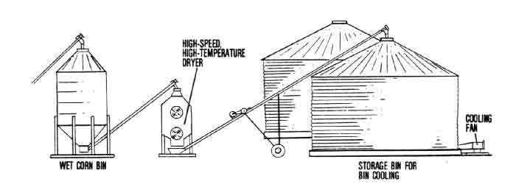

Figure 2. The bin cooling process allows grain to `slow-cool' in bins used for final storage, with some of the same benefits in drying performance and reduced kernel stress cracks as can be expected from dryeration.
The fan is then operated day and night while hot corn is being added, and continues to run until the cooling is completed, which is usually when the grain reaches an equilibrium temperature with the average of the day and night air. Assuming no additional drying is required, further fan operation is needed only to periodically aerate the grain for temperature control and safe storage.
Compared to dryeration, bin cooling is a faster process because the tempering step has been eliminated; the trade-off, however, is somewhat lower grain quality. Compared to cooling with high-speed dryers, bin cooling is slower because of the decreased air flow; but this usually results in less quality loss.

BENEFITS OF DRYERATION/BIN COOLING
As mentioned already, there are three main advantages of dryeration and bin cooling over high-temperature, high-speed corn drying: (1) a higher quality final product because of less kernel damage, (2) increased dryer output, and (3) improved fuel efficiency as a result of the second advantage. The latter two are of particular concern to livestock producers, while the first would be more important to cash grain farmers.

Reduced Kernel Damage
`Stress cracks' are fine, hairline cracks or fissures that occur in the meaty portion (endosperm) of the corn kernel just under the seed coat. They contribute to breakage and to excessive fine material, both of which cause storage problems, handling losses and price discounting. They are also a detriment in some types of corn processing, such as hominy production or dry milling in which large grits (pieces of endosperm) are more valuable than small grits and flour.
Stress cracks tend to develop when rapid cooling follows rapid drying, especially in grain dried rapidly through the 19 percent down to 14 percent moisture range with at least 5 points of moisture removal. Typical crack patterns are shown in Figure 3.
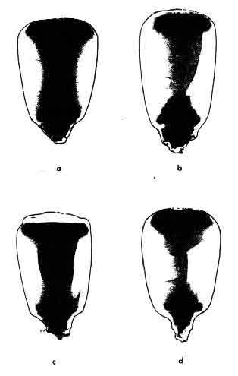

Figure 3. Stress cracks can occur In corn kernels dried with heated air and cooled too quickly. (A) Sound kernels, (B) single stress cracks, (C) multiple stress cracks, and (D) crazed or checked kernels.
Stress buildup from high-speed drying can be relieved by tempering and/or slow cooling. To what extent they prevent crack damage is shown in Table 1, which compares percent of checked kernels (the severest stress category) and breakage resulting from conventional drying vs. dryeration processes. Dryeration also tends to reduce the dust problems often associated with fast dried corn.

Increased Dryer Output
The increase in drying capacity with dryeration and bin cooling processes comes from a combination of factors including: (1) elimination of cooling in the dryer, (2) reduced moisture removal in the dryer, (3) increased drying efficiency and (4) use of higher drying temperatures. Let's briefly look at each one.
1. Elimination of cooling reduces total batch time by 15-30 minutes in a typical 200-300 bushel dryer. Converting the cooling section in a continuous-flow unit to additional heat area adds 50 percent more area for heat exposure and drying.
2.Reduced moisture removal in the dryer further shortens total batch time. This means the discharging grain is at a higher moisture content (2-2 1/2 points higher in the case of dryeration, 1-1 1/2 points in a bin cooling system). That moisture is removed later during the cooling process, in an amount dependent primarily on the difference between corn and cooling-air temperatures.

Table 1. Percentage of Stress Cracks and Breakage in Corn with Dryeration Vs. Conventional Drying/Cooling.*
Checked Kernel
Drying method kernels breakage
----------------------------------------------------------
Conventional drying/cooling 43.6 pct. 11.3 pct.
Dryeration 7.6 pct. 6.7 pct.
----------------------------------------------------------
*Based on three tests by each method tor drying corn from 25 down to
14 percent moisture. Breakage percentages determined on small samples
in a laboratory breakage tester.
To illustrate, consider 25-percent-moisture corn to be dried to 15 percent. In conventional drying, the corn is heat dried from 25 down to 15 1/2-16 percent and then fast-cooled, resulting in 1/2-1 percentage points additional moisture reduction. In bin cooling, the corn is discharged hot at 16-16 1/2 percent and its moisture reduced 1-1 1/2 additional percentage points during cooling. Indryeration, the corn is dried to 17-17 1/2 percent in the dryer then transferred to the dryeration bin for tempering, after which an additional 2-2% percentage points of moisture are removed during slow cooling.
3.Increased drying efficiency with dryeration is due primarily to the fact that 2-2% points of additional drying is done outside the dryer utilizing stored heat in the corn. Since in conventional drying the last point or two of moisture is the hardest to remove, dryeration brings about a typical 10-20 percent increase in energy efficiency. Since moisture removal in bin cooling is somewhat less, the energy efficiency gain is smaller, but still significant.
Another reason for better drying efficiency is the high amount of moisture removed per unit of air. In fact, the exhaust air is saturated at a temperature essentially equal to that of the hot corn (normally 120-140°F). To obtain an exhaust air condition equivalent to this in a deep-layer bin drying system, the air entering the grain would have to be nearly 500°F. In other words, the moisture-holding capacity of the air in dryeration and bin cooling is increased as though it were initially heated to 500° F. This is why outside air conditions have very little effect on dryeration cooling.
4.Use of higher drying temperatures increases dryer output and fuel efficiency. Maximum drying temperatures are controlled by the limits of kernel temperatures acceptable in corn for milling and other uses. This limit has been established at about 140°F. Since corn in a dryeration process is discharged at a moisture content 2-2 1/2% percent higher than in conventional drying, the kernel is slightly cooler for a given drying air temperature. This permits an increase in input air temperatures without exceeding the 140°F allowable kernel temperature. Drying air temperatures up to 240°F may be used.

Cooler Corn Placed into Storage
One additional benefit of dryeration/bin cooling is that the finished grain generally is cooler. Since nighttime temperatures are roughly 20 degrees below daytime highs in the Corn Belt, night cooling can decrease grain temperatures by 10-20°F. The result is 50-60°F grain, which means fewer temperature-related storage problems.

TYPES OF DRYERATION SYSTEMS

Two-Bin System
The most common dryeration setup on farms uses two dryeration bins, which are alternately filled and unloaded. In the cycle, hot corn from the high-speed dryer is added to the first dryeration bin for 16-24 hours, during which time the corn tempers. Hot corn delivery from the dryer is then diverted to the second bin, to allow time for the corn in the first bin to be cooled and transferred out to final storage unit or loaded out for marketing.
Dryeration normally requires 10-12 hours for grain cooling at air flow rates of around 3/4 (0.75) cubic feet per minute per bushel (cfm/bu.). This leaves 12-14 hours to complete the transfer of corn in the first bin while the second bin is being filled. Assuming the handling system can transfer one day's dryer output in about 2-4 hours, the cycle provides considerable flexibility for scheduling equipment.
Figure 4 illustrates two typical operating sequences for a two-bin dryeration system. Figure 4A is a 24-hour dryer operation day with a 24-hour dryeration cycle; and Figure 4B is a 16-hour dryer operation day with a 24-hour dryeration cycle. With either cycle, it is advantageous to complete dryeration cooling during the night; this results in roughly 20°F cooler grain for transfer to final storage.
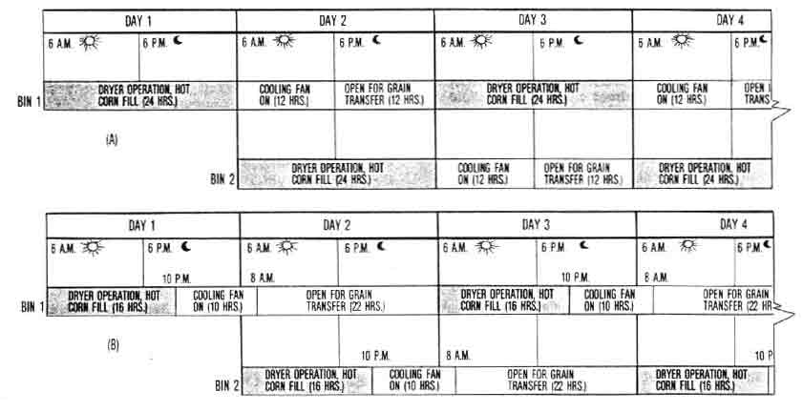

Figure 4. Common alternative sequences for a two-bin dryeration system. (A) 24-hour dryer day and 24-hour dryeration cycle. Hot corn from the dryer is delivered continuously to Bin 1 for 24 hours, then is diverted to Bin 2 for 24 hours, while Bin 1 is cooled (10-12 hours) and unloaded (2-4 hours), leaving 5-12 hours of open time for flexibility in each cycle. By shifting the start of each cycle to between 6-8 p.m., cooling can be completed overnight when air temperatures are lower, with the grain ready for transfer in the early morning. (B) 16-hour dryer day and 24-hour dryeration cycle. All cooling is completed overnight. with the grain ready for transfer early each morning. Except for grain transfer, each bin is idle roughly 20 hours in each cycle, assuming each can hold 16 hours of dryer-hot-corn output. Use of 3 or 4 smaller bins can increase cooling bin utilization, but at the expense of flexibility.
Overnight cooling is a natural schedule for the 16-hour dryer operation day system, with the cooling fan started when drying ceases at roughly 10 p.m. each day. Cooling will be completed by early forenoon, permitting grain transfer during the day.
With the 24-hour dryer cycle, the switch from one dryeration bin to the other may be scheduled to occur around 6 p.m. each day, rather than at 6 a.m. as shown in Figure 4A, to bring about overnight cooling and day- time grain transfer. If handling equipment scheduling for grain transfer is a problem during the day, it may be advantageous to schedule night hour handling after harvesting and hauling has ceased.
The dryeration cycle need not be 24 hours. In fact, many farmers use a less-than-24-hour `fixed cycle' to make scheduling of equipment and process flow easier. A fixed cycle means that the drying, tempering and cooling operations are performed at the same time each day.
With this sequence, the dryeration cycle is carried out with two bins, neither of which holds a volume of hot corn for 24 hours. Minimum size of each bin is a capacity sufficient to hold the hot corn output volume for a period equal to the cooling time (10-12 hours) plus the grain transfer time. The time that the hot corn flow must be shifted and dry, cooled corn transferred may change each day, and it may occur day or night.
One caution with dryeration cycles of less than 24 hours: do not schedule facility size and flow rates too tightly. A tight design leaves little room for variations in dryer output due to grain moisture, environmental conditions or equipment breakdowns. Also, some excess bin size may be desirable for expanding drying capacity in the future. Consider planning your grain drying layout so a third and possibly a fourth dryeration bin could be added later.

Three and Four-Bin Systems
As the volume of grain to be handled increases, three or four bins may work better than two. This is apt to be the case if dryeration bins are too small to accumulate a 24-hour hot corn output and especially if grain is marketed directly from the bins. Direct load-out for marketing can cause equipment scheduling problems that would be minimized by multiple dryeration bins.
Figure 5 shows a typical 24-hour operating cycle for a three-bin dryeration system. Each bin has a long period in each sequence during which it stands idle, either full of corn awaiting unloading or already unloaded awaiting refill. Remember, however, that if the dryeration bins are sized downward to less than a 24-hour hot corn receiving capacity, the storage bins will be used more efficiently.
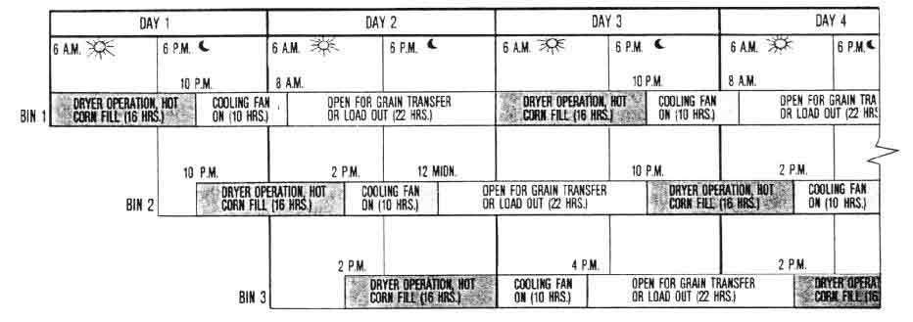

Figure 5. Typical operating sequence for a multiple-bin dryeration system-24-hour dryer day and 16-hour dryeration cycle. (A dryer hot-corn output of 300 bu./hr. would utilize three 4800-bu. bins.) The long open times for grain transfer is an advantage on large operations to increase flexibility, especially if marketing directly from dryeration bins. Bin 1 will almost recycle by the time the hot-corn fill is completed in Bin 2, but process control has to be very precise, which is difficult in complex systems.

Single-Bin, Multiple-Fill System
Another system popular on many farms, especially small ones, is to use one dryeration bin that holds more than one day's dryer output of hot corn. In fact, the bin may accumulate as much as 5 days' delivery of hot corn, provided the dryeration fan is correctly sized for varying grain depths. This system permits use of bins over 40 feet deep for dryeration, since the air flow required is only that needed to cool the amount of hot grain added in each fill layer.
The dryeration cycle depends on how long the dryer operates each day. A cycle accommodating a 16-hour drying period is presented in Figure 6. Here, hot corn is added to the dryeration bin from 6 a.m. till 10 p.m., at which time the cooling fan is started. The fan yields about 75 percent of the cooling by 6 a.m. the next morning, when it is turned off. (Each batch need not be cooled completely if a new layer is added the next day.)
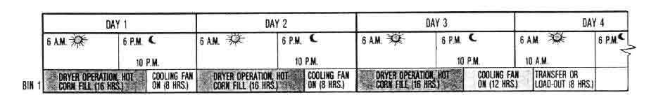

Figure 6. Typical operating sequence for a single-bin, multiple-layer-fill dryeration system. A layer of hot corn is added to the bin in 16 hours each day and partially cooled for 8 hours overnight; this is repeated for three consecutive days. The top fill must be cooled completely before the grain is transferred. Transfer can be carried out on rainy days regardless of the till level to maximize bin capacity. Hot corn fill can be continuous if, in the cooling process, the daily 6-8 hours fan operation does not push the cooling front into the newest layer until that grain has tempered for at least 4 hours.
The dryer is started again on the second day and the cycle repeated for a total of three to five consecutive fills, depending on weather and breakdowns. The final fill should be cooled completely before transferring the grain. Transfer time at flow rates of 2000-3000 bushels per hour may require 10 or more hours.
Bad weather may cause natural breaks that permit grain transfer without real lost time, but such breaks seldom perfectly match the desired cycle. The dryer operation can be shifted to a conventional cool-in-the-dryer mode during grain transfer. But this practice will reduce capacity, grain quality and energy efficiency.

TYPES OF BIN COOLING SYSTEMS
The number of bins is not important in a high-temperature grain drying process that uses bin cooling. Hot corn is usually delivered to one structure until it is filled, then to additional storage bins until harvest is completed or all storages are filled.
As previously stated, fans for bin cooling are started as soon as the grain depth in the bin is sufficient to maintain an air seal across the entire floor. Fans operate continuously any time hot corn is being added. If drying is interrupted before a bin is filled, run the fan until the corn is cooled.
Fan operation normally continues until the temperature of the grain is at or below the day-night average for that time of year. The fan is then altered to an aeration schedule to maintain desired grain temperatures for the storage season. This procedure assumes that little or no drying is needed after cooling is completed.

BIN OR STORAGE STRUCTURE SPECIFICATIONS

Types of Structure
For bin cooling. These structures are simply storage bins. Hopper- or conical-bottom units can seldom be justified cost-wise, because the storage is unloaded only once or twice a year. Flat storage units can be adapted for bin cooling, if adequate hot grain distribution and air systems are provided.
For dryeration. Bins used for dryeration may be flat- or hopper-bottomed, metal or concrete. Although most are round, some square and rectangular types have been used in new and existing farm structures, such as converted corn cribs. The problems in grain handling and air system adaptation of flat storages largely prohibit their use for dryeration.
Because grain is being transferred in and out of dryeration bins every 24 hours or less, fast and easy unloading is an important consideration in bin selection. Hopper- or conical-bottom bins empty quickly and completely-a significant advantage for large operations. However, the added cost of hoppered bins must be weighed against the equipment, management and labor involved in grain removal from a flat-bottom storage unit. The diameter of round bins with suspended metal hopper floors is usually limited to 24 feet.

Unloading Flat-Bottom, Round Bins
The simplest procedure for unloading in a flat-bottom, round bin is to allow a `grain hopper' to form by removing only the grain that flows freely by gravity from a center withdrawal point. Some operators accomplish this by first filling the bin with dry grain then withdrawing the center cone. Provided this grain remains dry, cool and in good condition, subsequent fills of hot corn are possible without completely emptying the bin.
The grain hopper surface may eventually become plugged with fines. Therefore, it should be checked regularly during the drying season and partially or completely removed any time fines or moisture accumulation become a problem. Before filling for final storage, the temporary grain hopper should be entirely removed.
Remember that the grain used in a flat-bottom bin to form a hopper reduces the bin's holding capacity. For bins with less than 30 feet of sidewall height, this can amount to 15-20 percent of the volume. Table 2 provides data to estimate the cone of grain remaining on the floor for various sizes of round metal bins.

Table 2. Grain Hopper Volume in Various Diameter Round Bins at 27° Angle of Repose.*
Sidewall
Bin grain Hopper volume
diameter height ---------------
in feet in feet Cu. ft. Bushels
------------------------------------------
14 3.2 307.3 245.8
18 4.2 681.2 545.0
21 5.0 1103.5 882.8
24 5.7 1671.4 1337.1
27 6.5 2407.4 1825.9
30 7.3 3332.1 2665.7
33 8.0 4467.6 3574.1
36 8.8 5834.8 4667.8
40 9.8 8057.3 6445.9
------------------------------------------
*Allows for an 18-inch diameter center clean-out opening.

Bin Sizing
The dryeration bin should be large enough to hold a grain supply equal to the dryer's rated hourly output times the number of hours of expected operation, plus at least 60 percent. The added 60 percent is based on increased dryer output in a dryeration process. With minimum moisture removal and a well-coordinated handling system, normal dryer output can be increased as much as 100 percent.
Realistically, dryeration bins should be sized for long-range farm needs rather than to fit a particular dryer. Allow for future growth by purchasing a dryeration bin that exceeds the daily drying capacity of your current dryer (adapted to dryeration) by a factor of 1.5 or more. Or, plan for additional dryeration bins in the future and in a location convenient to your handling system.

Table 3. Design Requirements for Air Flow Rates of 1/2, 3/4 and 1 Cfm/bu. In Dryeration and Bin Cooling of Shelled Corn for Various Bin Diameters and Grain Depths.*

Air volume Static pressure Fan power Duct area
Bin Grain Grain ------------ ---------------- --------------- --------------
dia. depth volume 1/2 3/4 1 1/2 3/4 1 1/2 3/4 1 1/2 3/4 1
--------------------------------------------------------------------------------------------------------
ft. ft. bu. cu.ft/min. in. water sq .ft. sq. in.

14 2.5 308 154 231 308 0.52 0.53 0.54 0.03 0.04 0.05 5 8 10
5.0 616 308 462 616 0.57 0.62 0.67 0.06 0.09 0.13 10 15 21
7.5 924 462 693 924 0.67 0.77 0.89 0.10 0.17 0.26 15 23 31
10.0 1232 616 924 1232 0.83 1.03 1.28 0.16 0.30 0.50 21 31 41
12.5 1539 770 1155 1539 1.03 1.36 1.80 0.25 0.49 0.87 26 38 51
15.0 1847 924 1385 1847 1.31 1.85 2.17 0.38 0.81 1.26 31 46 62
17.5 2155 1078 1616 2155 1.60 2.34 3.65 0.54 1.19 2.48 36 54 72
20.0 2463 1232 1847 2463 2.06 3.08 4.40 0.80 1.79 3.41 41 62 82
30.0 3695 1847 2771 3695 4.40 7.50 11.30 2.56 6.54 13.14 62 92 123
40.0 4926 2463 3695 4926 8.30 14.90 **** 6.43 17.32 **** 82 123 ****
50.0 6158 3079 4618 6158 14.00 **** **** 13.56 **** **** 103 **** ****

18 2.5 509 254 382 509 0.52 0.53 0.54 0.04 0.06 0.09 8 13 17
5.0 1018 509 763 1018 0.57 0.62 0.67 0.09 0.15 0.21 17 25 34
7.5 1527 763 1145 1527 0.67 0.77 0.89 0.16 0.28 0.43 25 38 51
10.0 2036 1018 1527 2036 0.83 1.03 1.28 0.27 0.49 0.82 34 51 68
12.5 2545 1272 1909 2545 1.03 1.36 1.80 0.41 0.82 1.44 42 64 85
15.0 3054 1527 2290 3054 1.31 1.85 2.17 0.63 1.33 2.09 51 76 102
17.5 3563 1781 2672 3563 1.60 2.34 3.65 0.90 1.97 4.09 59 89 119
20.0 4072 2036 3054 4072 2.06 3.08 4.40 1.32 2.96 5.64 68 102 136
30.0 6107 3054 4580 6107 4.40 7.50 11.30 4.23 10.81 21.72 102 153 204
40.0 8143 4072 6107 8143 8.30 14.90 **** 10.63 28.63 **** 136 204 ****
50.0 10179 5089 7634 10179 14.00 **** **** 22.42 **** **** 170 **** ****

21 2.5 693 346 520 693 0.52 0.53 0.54 0.06 0.09 0.12 12 17 23
5.0 1385 693 1039 1385 0.57 0.62 0.67 0.12 0.20 0.29 23 35 46
7.5 2078 1039 1559 2078 0.67 0.77 0.89 0.22 0.38 0.58 35 52 69
10.0 2771 1385 2078 2771 0.83 1.03 1.28 0.36 0.67 1.12 46 69 92
12.5 3464 1732 2598 3464 1.03 1.36 1.80 0.56 1.11 1.96 58 87 115
15.0 4156 2078 3117 4156 1.31 1.85 2.17 0.86 1.81 2.84 69 104 139
17.5 4849 2425 3637 4849 1.60 2.34 3.65 1.22 2.68 5.57 81 121 162
20.0 5542 2771 4156 5542 2.06 3.08 4.40 1.80 4.03 7.67 92 139 185
30.0 8313 4156 6235 9313 4.40 7.50 11.30 5.75 14.71 29.56 139 208 277
40.0 11084 5542 8313 11084 8.30 14.90 **** 14.47 38.97 **** 185 277 ****
50.0 13855 6927 10391 13855 14.00 **** **** 30.52 **** **** 231 **** ****

24 2.5 905 452 679 905 0.52 0.53 0.54 0.07 0.11 0.15 15 23 30
5.0 1810 905 1357 1810 0.57 0.62 0.67 0.16 0.26 0.38 30 45 60
7.5 2714 1357 2036 2714 0.67 0.77 0.89 0.29 0.49 0.76 45 68 90
10.0 3619 1810 2714 3619 0.83 1.03 1.28 0.47 0.88 1.46 60 90 121
12.5 4524 2262 3393 4524 1.03 1.36 1.80 0.73 1.45 2.56 75 113 151
15.0 5429 2714 4072 5429 1.31 1.85 2.17 1.12 2.37 3.71 90 136 181
17.5 6333 3167 4750 6333 1.60 2.34 3.65 1.59 3.50 7.27 106 158 211
20.0 7238 3619 5429 7238 2.06 3.08 4.40 2.35 5.26 10.02 121 181 241
30.0 10857 5429 8143 10857 4.40 7.50 11.30 7.52 19.22 38.61 181 271 362
40.0 14477 7238 10857 14477 8.30 14.90 **** 18.90 50.90 **** 241 362 ****
50.0 18096 9048 13572 18096 14.00 **** **** 39.86 **** **** 302 **** ****

27 2.5 1145 573 859 1145 0.52 0.53 0.54 0.09 0.14 0.19 19 29 38
5.0 2290 1145 1718 2290 0.57 0.62 0.67 0.21 0.34 0.48 38 57 76
7.5 3435 1718 2577 3435 0.67 0.77 0.89 0.36 0.62 0.96 57 86 115
10.0 4580 2290 3435 4580 0.83 1.03 1.28 0.60 1.11 1.84 76 115 153
12.5 5726 2863 4294 5726 1.03 1.36 1.80 0.93 1.84 3.24 95 143 191
15.0 6871 3435 5153 6871 1.31 1.85 2.17 1.42 3.00 4.69 115 172 229
17.5 8016 4008 6012 8016 1.60 2.34 3.65 2.02 4.43 9.21 134 200 267
20.0 9161 4580 6871 9161 2.06 3.08 4.40 2.97 6.66 12.68 153 229 305
30.0 13741 6871 10306 13741 4.40 7.50 11.30 9.51 24.32 48.86 229 344 458
40.0 18322 9161 13741 18322 8.30 14.90 **** 23.93 64.43 **** 305 458 ****
50.0 22902 11451 17177 22902 14.00 **** **** 50.45 **** **** 382 **** ****

30 2.5 1414 707 1060 1414 0.52 0.53 0.54 0.12 0.18 0.24 24 35 47
5.0 2827 1414 2121 2827 0.57 0.62 0.67 0.25 0.41 0.60 47 71 94
7.5 4241 2121 3181 4241 0.67 0.77 0.89 0.45 0.77 1.19 71 106 141
10.0 5655 2927 4241 5655 0.83 1.03 1.28 0.74 1.37 2.28 94 141 108
12.5 7069 3534 5301 7069 1.03 1.36 1.80 1.15 2.27 4.00 118 177 236
15.0 8482 4241 6362 8482 1.31 1.85 2.17 1.75 3.70 5.79 141 212 203
17.5 9896 4948 7422 9896 1.61 2.34 3.65 2.49 5.46 11.37 165 247 330
20.0 11310 5655 8482 11317 2.06 3.08 4.40 3.67 0.22 15.66 188 283 377
30.0 16965 8482 12724 16965 4.40 7.50 11.30 11.74 30.03 60.32 283 424 565
40.0 22620 11310 16965 22620 8.30 14.90 **** 29.54 79.54 **** 377 565 ****
50.0 28274 14137 21206 28274 14.00 **** **** 62.28 **** **** 471 **** ****

33 2.5 1711 855 1283 1711 0.52 0.53 0.54 0.14 0.21 0.26 29 43 57
5.0 3421 1711 2566 3421 0.57 0.62 0.67 0.31 0.50 0.72 57 86 114
7.5 5132 2566 3849 5132 0.67 0.77 0.89 0.54 0.93 1.44 86 128 171
10.0 6842 3421 5132 6842 0.83 1.03 1.28 0.89 1.66 2.76 114 171 228
12.5 8553 4277 6415 8553 1.03 1.36 1.00 1.39 2.75 4.84 143 214 285
15.0 10264 5132 7698 10264 1.31 1.85 2.17 2.12 4.48 7.01 171 257 342
17.5 11974 5987 8981 11974 1.60 2.34 3.65 3.01 6.61 13.75 200 299 399
20.0 13685 6842 10264 13685 2.06 3.08 4.40 4.44 9.95 18.95 228 342 456
30.0 20527 10264 15395 20527 4.40 7.50 11.30 14.21 36.33 72.99 342 513 684
40.0 27370 13685 20527 27370 8.30 14.90 **** 35.74 96.24 **** 456 684 ****
50.0 34212 17106 25659 34212 14.00 **** **** 75.36 **** **** 570 **** ****

36 2.5 2036 1018 1527 2036 0.52 0.53 0.54 0.17 0.25 0.35 34 51 68
5.0 4072 2036 3054 4072 0.57 0.62 0.67 0.37 0.60 0.86 68 102 136
7.5 6107 3054 4580 6107 0.67 0.77 0.89 0.64 1.11 1.71 102 153 204
10.0 8143 4072 6107 8143 0.83 1.03 1.20 1.06 1.98 3.28 136 204 271
12.5 10179 5089 7634 10179 1.03 1.36 1.80 1.65 3.27 5.77 170 254 339
15.0 12215 6107 9161 12215 1.31 1.85 2.17 2.62 5.33 8.34 204 305 407
17.5 14250 7125 10688 14250 1.60 2.34 3.65 3.59 7.87 16.37 238 356 475
20.0 16286 8143 12215 16286 2.06 3.08 4.40 5.28 11.84 22.55 271 407 543
30.0 24429 12215 18322 24429 4.40 7.50 11.30 16.91 43.24 86.86 407 611 814
40.0 32572 16286 24429 32572 8.30 14.90 **** 42.53 **** **** 543 **** ****

40 2.5 2513 1257 1885 2513 0.52 0.53 0.54 0.21 0.31 0.43 42 63 84
5.0 5027 2513 3770 5027 0.57 0.62 0.67 0.45 0.74 1.06 84 126 168
7.5 7540 3770 5655 7540 0.67 0.77 0.89 0.79 1.37 2.11 126 188 251
10.0 10053 5027 7540 10053 0.83 1.03 1.28 1.31 2.44 4.05 160 251 335
12.5 12566 6283 9425 12566 1.03 1.36 1.80 2.04 4.03 7.12 209 314 419
15.0 15080 7540 11310 15080 1.31 1.85 2.17 3.11 6.58 10.30 251 377 503
17.5 17593 8796 13195 17593 1.60 2.34 3.65 4.43 9.72 20.21 293 440 586
20.0 20106 10053 15080 20106 2.06 3.08 4.40 6.52 14.61 27.84 335 503 670
30.0 30159 15080 22620 30159 4.40 7.50 11.30 20.88 53.38 **** 503 754 ****
40.0 40213 20106 30159 40213 8.30 14.90 **** 52.51 **** **** 670 **** ****

42 2.5 2771 1385 2078 2771 0.52 0.53 0.54 0.23 0.35 0.47 46 69 92
5.0 5542 2771 4156 5542 0.57 0.62 0.67 9.50 0.81 1.17 92 139 185
7.5 8313 4156 6235 8313 0.67 0.77 0.89 0.88 1.51 2.33 138 208 277
10.0 11084 5542 8313 11084 0.83 1.03 1.28 1.45 2.69 4.46 185 277 369
12.5 13855 6927 10391 13855 1.03 1.36 1.80 2.25 4.45 7.85 231 346 462
15.0 16625 8313 12469 16625 1.31 1.85 2.17 3.43 7.26 11.35 277 316 554
17.5 19396 9698 14547 19396 1.60 2.34 3.65 4.88 10.71 22.28 323 485 647
20.0 22167 11084 16625 22167 2.06 3.08 4.40 7.18 16.11 30.69 369 554 736
30.0 33251 16625 24938 33251 4.40 7.50 11.30 23.02 58.85 **** 554 831 ****
40.0 44334 22167 33251 44334 8.03 14.80 **** 57.89 **** **** 739 **** ****

48 2.5 3619 1810 2714 3618 0.52 0.53 0.54 0.30 0.45 0.61 60 90 121
5.0 7238 3619 5429 7238 0.57 0.62 0.67 0.65 1.06 1.53 121 181 241
7.5 10857 5429 8143 10857 0.67 0.77 0.89 1.14 1.97 3.04 181 271 362
10.0 14477 7238 10857 14477 0.83 1.03 1.28 1.89 3.52 5.83 241 362 483
12.5 18086 9048 13572 18096 1.03 1.36 1.80 2.93 5.81 10.25 302 452 603
15.0 21715 10857 16286 21715 1.31 1.85 2.17 4.48 9.48 14.83 362 543 724
17.5 25334 12667 19000 25334 1.60 2.34 3.65 6.38 13.99 29.10 422 633 844
20.0 28953 14477 21715 28953 2.06 3.08 4.40 9.38 21.05 40.09 483 724 965
30.0 43430 21715 32572 43430 4.40 7.50 11.30 30.06 76.87 **** 724 **** ****
413.0 57906 28953 43430 57906 8.30 14.90 **** 75.62 **** **** 965 **** ****
------------------------------------------------------------------------------------------------------------
*Air flow resistance is based on ASAE standard data for clean shelled
corn, increased 50 percent for the fine material and compaction plus
0.5 inches of water column allowance for duct and entrance loss. Fan
horsepower is calculated on the basis of 50 percent "installed" fan
efficiency.

AIR DISTRIBUTION SYSTEMS AND SIZING
Systems for Various Type Bins
Round metal bins for dryeration or bin cooling have either full- or partial-perforated floors. If partial floors are used, they must contain a sufficient amount of perforated metal correctly placed in the bin floor to insure effective air distribution. Figure 7 illustrates several patterns for partial aeration systems.
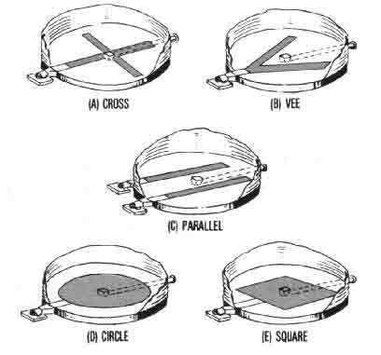

Figure 7. Any of these partial aeration duct and floor patterns should be satisfactory, as long as there is enough total area for air to pass through. However, more producers are using completely perforated floors to provide for future bin drying if needed.
The present trend, however, is toward full-perforated floors. In fact, they are essential for bin drying if more than 1-2 points of moisture must be removed, and if air flow rates and air distribution requirements for drying exceed the capacity of partial-aeration floor systems. The added cost of a full-perforated floor may be partly offset because it facilitates conversion to bin drying at a later date. In fact, the higher cost is minimal when figured on a per-bushel basis for a bin that will be used 12-25 years.
Hopper- or conical-bottom bins normally use perforated ducts running up and down the sloped surface, as illustrated in Figure 8. Either full-round or half-round ducts should work satisfactorily. But regardless of type, they must be well anchored because of the tremendous forces acting on them during bin unloading.
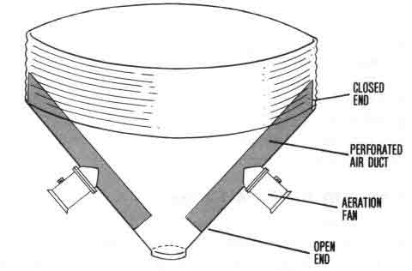

Figure 8. A conical- or hopper-bottom bin, which permits fast unloading, is particularly valuable for dryeration. The aeration ducts (whether full- or half-round) must be substantial and securely anchored to withstand the force of grain during unloading.
Flat storages are usually equipped with a perforated duct system on top of the concrete floor. There are obvious problems in working around or removing and storing above-floor ducts during grain unloading. However, sub-floor duct systems or full-perforated floors are costly and difficult to design sufficient to support heavy-wheeled equipment during load-out or for alternate use of the structure.

Determining Perforated Floor and Duct Areas
Perforated bin floors and ducts should allow the air velocity entering the grain to be 30 feet per minute (fpm) or less. Therefore, to determine perforated floor or duct surface area, divide the total air flow requirement by 30 fpm.
Assume, for example, 4000 bushels of hot corn are to be cooled at one time with an air flow rate of 0.75 cfm/bu. The total air flow needed is 3000 cfm (4000 bu. x 0.75 cfm/bu.); and the perforated duct or floor surface area, then, would be 100 sq.ft. (3000 cfm ÷ 30 fpm).
For circular ducts, only 80 percent of the surface is available because the ducts rest on the floor or against a wall. Thus, 30 feet of a 16-inch diameter round duct or 50 feet of a flat, perforated strip 2 feet wide would be adequate (see Table 3).
In general, air velocities through ducts and in sub-floor tunnels should not exceed 1500 fpm. To find duct or tunnel cross-sectional area, therefore, simply divide total air flow by 1500 fpm. In the example above, the duct cross-sectional area would be 2 sq.ft. (3000 cfm ÷ 1500 fpm). Air transitions and entrance collars should not restrict air flow.

AIR FLOW DIRECTION, RATES AND FAN REQUIREMENTS

Air Flow Direction
Upward air flow is generally recommended in both dryeration and bin cooling, even though it may result in more condensation on exposed bin walls and roof than with a suction system. Upward air flow cools the grain on the top surface last, making it easier to determine when cooling is complete. In fact, upward air flow is essential for any dryeration procedure involving layered fills and for bin cooling in which hot corn is continuously cooled as it is added to the bin.
It takes a minimum of 4 hours for a cooling front to traverse the grain depth. Thus, hot corn on top will lie for at least that long before being contacted by the leading edge of the front. Because this minimum recommended temper time exists naturally in the dryeration process, the inherent 4-hour cooling lag allows you to start the cooling fan immediately upon terminating bin filling.
A drawback to downward air flow becomes evident when cooling is ended in a bin only partly filled with hot corn. If this corn is cooled before more hot corn is added, all the heat and moisture from any corn added to the top must be moved through the cool corn underneath. This causes the first layer to be reheated and wetted, adding more time to the cooling cycle.
Another difficulty with downward air movement occurs if cooling is intermittent or interrupted. A bin full of hot corn acts much like a chimney when the fan is not running, drawing cool air in at the bottom. Hot corn near the floor or ventilating duct may cool enough between periods of fan operation so that water will condense on it when operation is resumed. Condensation will then occur when warm, moisture-laden air hits the cooled area. In freezing weather, this condition may essentially seal off the ventilation duct.

Dryeration Air Flow Rates
For the dryeration process, plan on a per-bushel air flow of between 0.5 and 1.0 cubic feet per minute (cfm/bu.). A design calling for 0.5 cfm/bu. when the bin is full produces higher air flow rates for smaller grain quantities but probably will still not exceed 1.0 cfm/bu. Rates in the 0.5-1.0 range normally cool the corn in 10-20 hours and still maintain air velocities through the grain low enough to obtain high moisture-saturation of the exhaust air.
The principle, `If an inch is enough, don't give it two,' applies in selecting air flow rates for dryeration. Increasing air flow speeds up the cooling process but forces the heated air out of the corn before it has time to pick up a full moisture load. Faster cooling may also increase stress crack formation.

Bin Cooling Air Flow Rates
The air flow rates for bin cooling range from below the level for dryeration to considerably above it. Since bin cooling in final storage does not require clearing the structure for rapid re-use, the cooling rate can be considerably below the 0.5 cfm/bu. minimum for effective dryeration. However, all hot corn put in the bin should be cooled within 48 hours.
A number of farmers practice bin cooling using a fan and bin originally designed for bin drying, or they may have built a new unit designed for a combination high-speed/bin drying system. Thus, air flow rates for these low-temperature drying systems may exceed the 1.0 cfm/bu. upper limit recommended for dryeration, especially if the bin is only partially full.
In cold weather or on cold nights, bin cooling at very low air flow rates may result in excessive exhaust air condensation on bin walls and roof, and thus moisture running back into the grain.

Fan Requirements
Fan horsepower, static pressure and duct surface area requirements for dryeration and bin cooling air flow rates of 0.5, 0.75 and 1.0 cfm/bu., in bins 14 to 48 feet in diameter, are shown in Table 3. In general, the higher air flow rates work best on shallow depths and the lower rates on deep bins. Such application tends to minimize both uniformity problems in cooling and the horsepower requirement.
Note from Table 3 that fan horsepower increases roughly five times when the air flow rate doubles from 0.5 to 1.0 cfm/bu. Also notice that to maintain the same air flow per bushel at twice the depth requires a 10-fold increase in horsepower.

ADAPTING DRYING EQUIPMENT TO DRYERATION/BIN COOLING
Batch dryers can be adapted to dryeration and bin cooling simply by eliminating cooling and transferring the hot corn directly to a dryeration or cooling bin. Most automatic batch units are easily programmed to shift directly from `heat' to `unload.'
Continuous-flow and multiple-chambered batch dryers can also be adapted to hot corn delivery by converting the cooling section to a heat section. Normally, the cooling section in such dryers occupies from a fourth to a third of the total drying volume; so adding extra heating area may actually improve dryer capacity 30-50 percent--a real boost in drying speed.
Remember, however, that a continuous-flow dryer with a single fan for both the heat and cooling sections is more difficult to convert. And always check with the manufacturer when considering any change in the burner and control systems. Also, before finalizing a decision to modify an existing dryer, weigh the alternative of trading it in on a new one it it's getting old, it conversion is too difficult, or if you're unsure of yourself.

DETERMINING PROPER HANDLING RATES
Handling rates for dryeration and bin cooling systems should be increased in proportion to any increase in drying capacity. If this is not done, extra handling equipment time must be committed to servicing the increased dryer throughput and, in dryeration, transferring the dryerated grain.
In the case of a batch dryer with a single leg elevator, for instance, a 60 percent increase in capacity will tie up the handling system 60 percent more in hot corn handling. On the other hand, for continuous-flow dryers (which often use one handling system for `dry or hot grain removal' and another for `grain receiving'), the conflict may be minimal, assuming the dry grain handling rate can be expanded to meet the needs of a 60-100 percent increase in flow rate for hot corn delivery.
Many medium-sized farms have dry or hot corn handling equipment capable of moving 2500-3000 bushels per hour. A dryer delivering 5000 bushels of corn for 24 hours in a conventional dry-and-cool mode should be able to deliver 8000 bushels of hot corn per day using dryeration. Transferring this grain after it is cooled at a handling rate of 2500 bushel per hour will take over 3 hours.
Even with this extra 3-hour handling operation, the capacity of the total drying process using dryeration is considerably above the capacity of a conventional operation. Remember, the volume of grain that requires high-speed, high-temperature drying also requires a well-coordinated, ready-to-go handling system. And although dryeration adds one extra handling of the grain, the larger volume tends to `force' an improved handling layout (whether or not dryeration is involved).
The `proper' handling rate for a dryeration system on a given farm is the total of the rates for. (1) corn receiving, (2) dryer loading, (3) dryeration bin loading, (4) dryeration bin unloading, (5) hot corn transfer and (6) transfer to storage or load out. A handling rate of 2500-3000 bushel per hour seems to fit many farms and matches the capacity of 8-inch auger equipment Large farms often use equipment in the 4000-6000 bushel per hour range.
(Note: The capacity of most handling equipment is somewhat lower when handling hot corn, because it is wet, sticky and does not flow as easily as cool, dry corn does.)

PATTERN LAYOUTS FOR DRYERATION/BIN COOLING
Any grain drying process using high-temperature, high-speed drying should be planned to incorporate dryeration or bin cooling. The grain bin you build today has a life expectancy of 20-25 years. Future energy costs and availability suggest the need for a flexible plan that `builds in' alternatives.
The `costs' of long-range planning are primarily planning time plus the space required in the layout. If pre-planned options are never needed, the consequence is small. But to plan without considering available options could be costly.
One suggestion is to develop a plan that would meet your estimated needs 3-5 years down the road; then double it! Don't consider this doubled plan ridiculous. Force yourself to spell out how you would plan the facility if you were faced with that kind of an expansion need.
When the doubled plan is completed, simply scale it back to fit your current needs and pocketbook. But try to scale it down in ways that keep growth opportunities open. Most well-engineered plans can be doubled without serious compromise. Planning for the next 3-5 years and doubling that to a 6-10 year plan, implies that the last plan can be doubled again to 12-20 years without much trouble.
Several pattern layouts for drying facilities that include dryeration and bin cooling are shown in Figure 9.
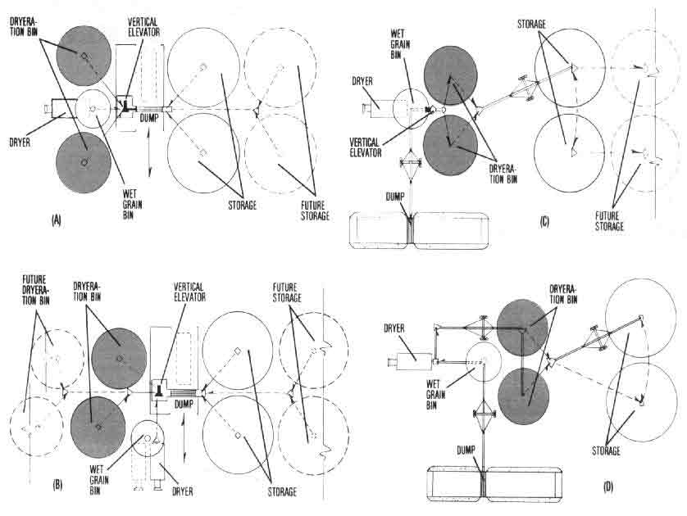

Figure 9. Grain drying facility schemes to accommodate dryeration and bin cooling. (A) Dryeration layout utilizing flat-bottom cooling bins and vertical or inclined elevator systems. (B) Similar to layout A, with the wet holding bin and dryer placed parallel to the drive-through area. (Added storage units serviced best with top conveyors). (C) Similar to layout A, but uses inclined elevators for wet grain receiving and dry grain transfer, and a vertical elevator for hot corn transfer to the dryeration bins. (D) Same as layout C, but with inclined conveyors throughout. All layouts are adaptable to vertical elevator handling and possible enclosure of the center building later. One or both of the dryeration bins in all layouts can be replaced with hopper-bottom bins. Use of bin cooling would eliminate the need to rehandle grain, but results are not as good as with dryeration.

OPERATION AND MANAGEMENT TIPS

Controlling Condensation on Bin Surfaces
There is much moisture condensation during corn cooling in a dryeration system and, to a lesser degree, in bin cooling. Moisture condenses on the underside of the bin roof, inside exposed bin walls and on any wall surface in contact with the hot, sweating corn. Moisture drip and runback from the roof and exposed wall can rewet those kernels on the surface and adjacent to the wall by as much as 10 points or more in moisture content.
However, when dryeration-cooled grain is transferred to the final storage facility, the rewetted kernels blend into dry grain with little problem. Kernels may stick to the inside surface of the dryeration bin; but it left in place, the quantity and appearance will be essentially unchanged and will usually not present a problem, even with continued filling and unloading.
The tempering period tends to produce the greatest amount of vapor. This is because of the relatively of hot grain being cooled in the bin. The problem is somewhat lessened in concrete silos, because heavy walls do not change temperature quickly. When nighttime temperatures remain above 50° F, condensation is minimized. On nights when temperatures are near freezing, however, condensation is substantial.
Condensate runback from bin surfaces in both dryeration and bin cooling can be minimized by managing the cooling process through one or more of the following practices:
* Reduce or eliminate tempering as the weather gets colder.
* Cool tempered corn during the day only, when the bin surface is warmest.
* Practice bin cooling only in the early part of the season. (Late season condensate runback can be severe; without grain transfer to help blend rewetted grain into dry grain, spoilage risk may be high.)
* Consider bin-cooling only that grain intended for short-term storage, while reducing or eliminating it on grain for long-term storage.
* Bin cool only the lower half of a storage quantity and not the upper half. (The rationale is that a higher air flow level on the smaller amount of grain may more effectively re-evaporate any condensed moisture.)
* Use a fan on top of the bin to quickly move air out of the overspace in the bin.

Controlling Condensation In Gravity Handling Systems
Moisture generated during cooling is potentially most troublesome when the handling system includes vertical legs and interconnected gravity spouts. The airborne moisture is carried up a spout to the top of the leg. As condensation occurs, moisture runs down the spouts connected to other bins in the system which may already be filled with newly-dried, cooled corn.
Also moisture tends to increase corrosion, especially in the presence of heat. Thus, permitting moisture from the dryeration and cooling bins to travel throughout the grain handling equipment system not only shortens equipment life but contributes to unsightly rust streaking on structures and equipment.
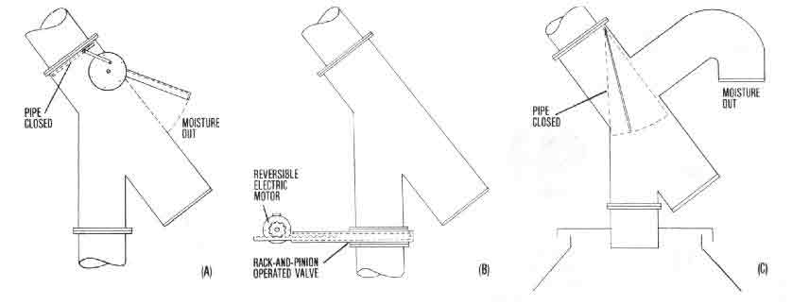

Figure 10. These alternative methods for blocking or bypassing gravity grain spouts prevent moisture vapor from traveling up the pipes or elevator leg and subsequent condensation which could run down any pipe in the system to rewet dried grain in storage. All methods should open automatically or manually when needed and have signal devices to indicate whether they are open or closed.
The most important step in controlling condensation in vertical handling equipment is to realize that it is a problem! Here, then, are some things that should help:
* Make provision to be able to disconnect the supply spout to the hot corn bin.
* Install a device to block or bypass air flow. Figure 10 shows several ways to do this.
* Install an exhaust ventilation fan to remove air from the top of the dryeration bin (Figure 1). This should be a high-volume, low-static-pressure fan sized to move roughly 25 percent more air than the dryeration ton delivers. The `additional' air that is moved will he drawn from openings around the bin root and down the gravity supply spout, thus eliminating the possibility of moisture moving up the spout. The exhaust fan should be wired to operate automatically when hot corn is being added or tempered, or when the dryeration cooling fan is running.
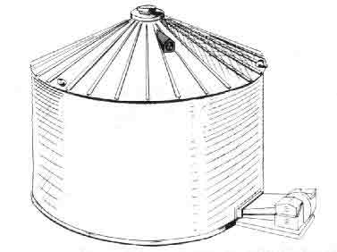

Figure 11. A roof exhaust fan can prevent moisture condensation on exposed metal walls and roof while grain is being slow-cooled. Capacity should be about 25 percent greater than the cooling fan to blow out moisture vapor quickly.

Measuring Hot Corn Moisture Content
Because the temperature of hot corn changes so rapidly, its moisture content cannot be measured accurately with electronic moisture meters. Moisture tends to condense on the contact surfaces between the moisture meter and the grain; this will impair accuracy.
A workable solution is to cool the grain sample quickly to the same temperature as the air around the moisture meter and then measure the moisture. (It the sample is cooled immediately after removal from the dryer, it will lose little moisture.) Using almost any small fan, including household ventilation and air circulation types, a 1-pound sample in a screened-bottom pan or a container shaped totally from hardware cloth can be cooled in 3-5 minutes, especially if the sample is stirred occasionally (Figure 12)
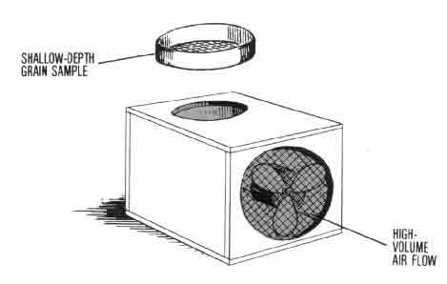

Figure 12. A grain sample should be cooled before testing for moisture content. A shallow layer of sample in a screen tray over a high rate of air flow will cool quickly before much moisture can evaporate.
At least three samples should be taken for moisture measurements during unloading. Preferably space them to coincide with the first, middle and last thirds of the dryer quantity.

Measuring Hot Corn Temperature
A simple way to measure corn temperature is to place a sample in a large-mouth thermos bottle containing a thermometer that reads up to 200° F (e.g, a candy thermometer). Fill the thermos quickly, insert the thermometer and read the temperature as soon as the reading stabilizes.
Leave the hot grain in the thermos until just before the next sample is taken. This keeps the container warm and reduces the heat drawn from the new sample. Generally, the samples for moisture content and temperature are taken at the same time.

Estimating Moisture Loss During Cooling
The amount of drying that occurs during the cooling process will depend on the amount of stored heat in the corn and how efficiently that heat is used. Theoretically, corn at 140°F has enough stored heat to remove a maximum of 3 points of moisture when cooled to 60° F. In actual tests, the moisture loss is about two-thirds of this maximum, or 2 - 2 1/2 points.

Determining When Grain is Cool
Grain should be considered cooled when it is at least the same temperature as the air was when fan operation started some 10-12 hours earlier. Don't expect all of the grain to equal the `air temperature' when you check it on a frosty morning. The air at that moment might have been that temperature only the previous hour or so. Thus, you can hardly expect all of the grain to be at air temperature, because the grain cooling rate is relatively slow.
Also, cooling may be slower where air flow has been restricted, such as under the filling spout where fines accumulate. Since the corn will be mixed with cooler grain when the dryeration bin is unloaded, small pockets of uncooled grain can be tolerated.
Measuring grain temperatures in the upper layer with a temperature probe or thermometer is recommended. Some installations have permanent thermocouple systems to monitor grain temperatures throughout the bin. It is also a good idea to check the grain temperature when it is being transferred.

Storing the Cooled Grain
Even distribution of fine materials (`fines') in the dryeration bin is important for good air distribution. Hot fine material is usually sticky; and it accumulates and packs under the grain spout. A grain distributor helps correct this condition.
When the corn is transferred from the cooling bin to storage, distributing or removing fines and keeping the grain uniformly cool with an adequate, correctly-operated aeration system should permit storage of 14 percent moisture corn on a long-term basis. Corn to be stored only during winter months may be carried at 15 - 15 1/2 percent.
An experienced operator using modern grain storage equipment and technology does not need to overdry his grain one to two points `just to be safe.' For each point grain is overdried, 1 1/4 percent of its weight is lost. With corn worth about 4 cents a pound, the loss amounts to 3 cents per bushel for each point of overdrying!

Practicing Bin Safety
The moisture-laden air exhausted from cooling bins at 120-140°F may be oppressive, if not dangerous to breathe. If you must enter a bin with flow or spoilage problems, at least two people should be standing by in case help is needed. With two people at hand, one can go for help while the other administers aid.
Entering a grain bin during unloading or when unloading equipment is operating is extremely dangerous and must be avoided. The down-pull of flowing grain, in addition to normal foot and leg penetration in the dry grain, frequently makes it impossible for a person to work free, once trapped. He will be drawn quickly under the grain or into the conveying equipment and injured or suffocated.

ESTIMATING DRYERATION/BIN COOLING COSTS

Dryeration Costs
Fixed costs. Those fixed costs associated with the installation of a dryeration system stem primarily from: (1) the extra investment in the dryeration cooling bins vs. the same type and size bins used for storage, (2) any special equipment or flow arrangements required for the extra handling of the hot corn, and (3) any drying equipment modifications or additions necessary to carry out the process.
On existing installations that use conventional round, metal, flat-bottom storage bins and high-speed, batch drying equipment, the adaptation costs are primarily for increasing air flow in existing storage bins, or possibly decreasing it in converted bin-drying units, plus installation of grain delivery conveyors or spouting and grain spreaders.
If a continuous-flow, high-speed dryer is involved, there may also be the cost of an additional burner and control system to convert the cooling section of the dryer to a heat section. Installing a separate set of controls allows you both to run the new burner at a different (probably lower) temperature than the primary heat section, and to turn it off for an immediate shift to a conventional cool-in-the-dryer mode.
The above anticipated fixed costs for a dryeration system assume that the dryeration cooling bins can also function as storage bins at the end of the season. If this increased storage capacity is desirable and needed, the only added cost attributable solely to the dryeration process is to equip or size the bin and fan for effective dryeration cooling. The higher air flows of dryeration for cooling compared to normal aeration for dry storage conditioning means larger fans and a full false floor or an extensive duct system (see Table 3).
In considering new bin units for dryeration cooling, they may be of special design (such as hopper- or conical-bottom) or special size (possibly smaller than most desirable for storage) to better accommodate an efficient dryeration process. If so, these increased costs should also be charged to the dryeration process.
Table 4 presents percentages useful in estimating the annual fixed cost of alternative dryeration processes.

Table 4. Annual Fixed Cost Percentage Rates for Dryeration and Bin Cooling Equipment.

Annual fixed cost rates
-----------------------------------
Repairs,
Expected Depreci- taxes and
Item life ation Interest* insurance Total
---------------------------------------------------------------------------------------
years percent

Storage facilities and components
(bins, false floors, ducts, etc.) 20 5.0 6 5 3 0 14.5

Dryeration and bin cooling fans
(unheated air fans: propeller
and centrifugal) 10 100 6.5 3.0 19.5

Auger conveyors and grain
spreaders (portable and sta-
tionary units, sweeps, etc.) 7 145 6.5 3.0 24.0

Bucket elevators and support
systems (receiving dumps,
spouting, turnheads, etc.) 12 8.3 6.5 3.0 17.8

High-speed dryers and compo-
nents (batch and continuous-
flow units) 7 14.5 6.5 3.0 24.0

Bin dryers and components (fans
and heaters, stirring devices,
continuous unloaders, etc.) 7 14 5 6.5 3.0 24.0

Electric power service system
(switches, wiring, phase con-
verters, etc.) 10 10.0 6.5 3.0 19.5

Gas or oil service equipment
(tanks, plumbing, valves, etc.) 10 10.0 6.5 3.0 19.5
-----------------------------------------------------------------------------------------
* Based on a rate of 13 percent per year, averaged to half rate on
full initial value or full rate applied to average for depreciated
life.

Variable costs. Dryeration system operating costs are relatively small compared to drying and storing grain, except for the labor involved in one extra grain rehandling in dryeration. Following are three typical variable costs involved and how to figure them.
Electricity cost to power the dryeration cooling fan can be estimated on the basis of 1 kilowatt-hour (kw-hr.) per fan horsepower per hour of fan operation. For example, assuming a cooling time of roughly 12 hours for each dryeration cycle (A cycle in a two-bin dryeration system will normally be one dryeration bin fill or partial fill in one day and cooled and unloaded/transferred the next.), a 27-foot diameter, round metal bin filled 15-feet deep with 6870 bushels of hot corn requires a 3.0 horsepower fan to provide an airflow of 3/4 cfm/bu. for dryeration cooling (from Table 3). In a 12-hour cooling period, therefore, the fan would require a total of 36 kw-hr. for a complete cycle (3 kw-hr./hr. x 12 hr.). If electricity costs 5 cents/kw-hr., dryeration cooling for the 6870 bushels would be $1.80 or 1/40th cent per bushel.
Electricity cost for the extra grain handling involved in dryeration will be very small Vertical bucket elevators deliver roughly 300-400 bushels per hour per horsepower, elevating to a 70-80 foot height. An 8-inch inclined auger will deliver roughly 150-200 bushels per hour per horsepower in a 60-foot length elevating to a 30-35 foot fill height. Thus, at 5 cents/kw-hr., the electricity per handling for either system is approximately 1/50th cent per bushel ($.05 ÷ 300 bushels and $.05 ÷ 150 bushels). Remember that this considers only power costs; the fixed or annual ownership costs must be calculated using Table 4.
Labor cost for the extra handling following dryeration cooling may not all be attributable to dryeration. Normally, the operation involves 2-4 hours per day at transfer rates of 2500-3000 bushels per hour. But such transfer is usually done on a semi-automatic basis, with the operator doing something else while transfer continues.
A more critical factor may be the equipment scheduling required, assuming the same handling system services grain receiving to the dryer or wet holding bin and possibly hot grain take-away from the dryer. Equipment scheduling in well-designed systems with adequate flow rates is not a serious problem in the most common dryeration one- or two-bin systems. The grain is usually transferred early in the morning, before a new day's harvest operation requires a heavy receiving schedule.
Cost savings. On the plus side of any dryeration system cost analysis are: a sharply-increased drying rate, a lower drying fuel cost, a higher quality product and a more storable product (delivered to storage at 50-60°F instead of 75-80°F).
Almost any high-speed batch dryer, new or used, will deliver five batches in the same time it previously delivered three, when operation is switched to a dryeration procedure on 10 percentage points of moisture removal. This is a 50-60 percent increase in throughput rate, and will result in an overall sharp increase in both quantity and quality of grain delivered to the storage per day, even with the added handling operation and time. If the time can be telescoped onto other useful tasks, it may represent no real penalty in overall system performance. The same general conclusions apply to a continuous flow dryer that can be adapted for dryeration by using heat on the cooling section.

Bin Cooling Costs
Estimating the annual fixed or ownership costs and the variable costs for bin cooling involves the same cost relationships as for the dryeration process. The difference is that bin cooling does not involve the extra grain handling, because there is no intermediate dryeration bin. Thus, the handling system can and usually will he the same as that for a conventional cool-in-the-dryer system which delivers dry grain to storage.
The storages for bin cooling may require a higher air flow rate and more elaborate air distribution system than that required for aeration of dry grain. These added costs, if any, are chargeable to the system.
Although the drying rate and fuel efficiency increases in bin cooling are not as dramatic as for dryeration, they are still significant as discussed earlier. These benefits should be added to the plus side of any cost analysis evaluating bin cooling.

SUMMARY
The dryeration and bin cooling processes used to dry and condition grain combine the advantages of increased speed or throughput with improved energy efficiency while maintaining product quality. The results are often startlingly good. These processes grew out of a research and extension program begun almost 20 years ago, long before energy availability and cost were major considerations in agricultural production.
Improved grain quality was the original motivation behind dryeration research. Today, the steadily increasing importance of grain in international trade, especially corn and soybeans, has only underscored the value of quality, especially as it relates to breakage in corn.
The benefit of dryeration is so specific and positive in reducing the susceptibility of corn to breakage during handling that the practice must be considered in the planning of any new grain facility or the renovation and updating of existing ones. This generalization applies to all levels of the grain industry, whether farm, country elevator or inland or seaport terminal.
Bin cooling is most applicable to farm and small elevator installations. If done in conjunction with bin drying to slowly complete the final 2-4 points of moisture removal in the same bin in which grain cooling was completed, the improved capacity and fuel efficiency and the reduced quality stress can be very significant.

Related Publications
Single copies of the following Purdue Extension publications dealing with grain drying and handling are available free to Indiana residents from their county Cooperative Extension Service offices or by writing to the Media Distribution Center, 301 S. 2nd St., Lafayette, IN 47905-1232:
AE-82 "Harvesting. Drying and Storing Grain Sorghum"
AE-90 "Managing Grain for Year-Bound Storage"
AE-91 "Temporary Corn Storage in Outdoor Piles"
AE-99 "Adapting Silage Silos for Dry Grain Storage"
AE-106 "Fan Sizing and Application for Bin Drying/Cooling of Grain"
AE-108 "Soar Heat for Grain Drying"
AED-20 "Managing Dry Grain in Storage"
ID-96 "Double Cropping Winter Wheat and Soybeans in Indiana"
The following Midwest Plan Service publications are available at the cost indicated from the Farm Building Plan Service, Agricultural Engineering Building, Purdue University, West Lafayette, IN 47907:
MWPS-13 "Planning Grain-Feed Handling" ($2.50)
MWPS-22 "Low Temperature and Solar Grain Drying" ($3.00)
For more information, contact Dirk Maier, Agricultural and Biological Engineering, phone: 317-494-1175 or e-mail: maier@ecn.purdue.edu

New 9/80
Cooperative Extension work in Agriculture and Home Economics, State of Indiana, Purdue University and U.S. Department of Agriculture cooperating: H.A. Wadsworth, Director, West Lafayette, IN. Issued in furtherance of the acts of May 8 and June 30, 1914. The Cooperative Extension Service of Purdue University is an equal opportunity/equal access institution.

Contents
Introduction
Adaptability of Drying Systems to Solar Energy
Characteristics of Solar Energy
Economics of Solar Grain Drying
Ways to improve cost effectiveness
Determining Solar Heat Availability
Collector tilt
Types of Solar Collectors
Plastic collectors
Bare-plate collectors
Covered-plate collectors
Suspended-plate collectors
Transporting Collected Heat
Sizing the Solar Collector
Solar Grain Drying System Design Examples
Full-bin, low-temperature system
Layer drying system with grain stirring
Summary of Management Considerations in Solar Grain Drying

SOLAR HEAT FOR GRAIN DRYING- SELECTION, PERFORMANCE, MANAGEMENT
Corn requires more energy for artificial drying than any other crop. In fact, it often takes more energy to dry corn than it does to prepare the seed bed, plant, cultivate and harvest.
Being Indiana's largest cash crop, most farmers try to harvest their corn within a concentrated few weeks in the fall in order to minimize field losses. Thus, it is usually harvested with more excess moisture than other grains, which explains the high energy requirement for drying.
In Indiana, the energy used to dry corn is estimated at 7.65 trillion BTUs per year-a fuel equivalent of 85 million gallons of LP gas! A rather significant amount of this fuel equivalent could be provided by solar energy. `Tapping into the sun' would not only help conserve dwindling fossil fuel supplies, but also hold down your drying costs in the face of increasing fuel prices.
The purpose of this publication is first to help you evaluate the potential of solar grain drying for your farm enterprise, including where it works or doesn't work, economic considerations, and facility and equipment requirements. Then we will present suggested procedures for determining solar grain drying system design specifications and review the management needed to insure efficient operation.

ADAPTABILITY OF DRYING SYSTEMS TO SOLAR HEAT
Generally, high-speed, high-temperature drying is not adaptable to solar energy use for three main reasons. (1) Simple solar collectors cannot provide a high enough drying temperature; (2) the amount of collector surface required to supply all the heat for even a moderate size high-temperature dryer is unrealistically large (nearly an acre); and (3) solar energy is available only when the sun shines. If you already have a large collector, such as a roof unit for warming livestock shelters, it might be used advantageously with high-speed dryers to pre-heat the drying air a few degrees.
Low-temperature drying, on the other hand, is quite well adapted to solar energy. Being a slow process which uses natural or slightly heated air to dry the grain while in storage, solar energy can provide the supplemental heat to raise the temperature and reduce the relative humidity of the drying air.
Solar energy is also applicable to combination high- and low-temperature drying. Under this system, a high-speed, high-temperature dryer is used first to bring the high-moisture harvested grain down to about 20-22 percent moisture. Then the grain is transferred--without cooling--to a slow-speed dryer for final drying to its proper storage moisture content, using natural or solar heated air. The aim of this combination system is to reduce grain moisture quickly to a level where cheaper low-temperature drying can be done without danger of undue spoilage.

CHARACTERISTICS OF SOLAR ENERGY
Solar energy has four principal characteristics that affect its adaptability to grain drying-(1) it is a diffuse, low-grade energy; (2) it is available at the point of use; (3) it is intermittent; and (4) it is capital intensive. Let's see what bearing these attributes might have on grain drying requirements.
* Direct collection of diffuse, low-grade solar energy produces only a moderate rise in temperature; but this is usually sufficient to meet the requirements for low-temperature drying. Air entering a solar collector for an in-storage drying system is heated only a few degrees. Since heat loss is proportional to the average difference between ambient (outdoor) and collector temperatures, the losses from collectors used in low-temperature drying are small. Therefore, relatively low-cost collectors are effective for grain drying.
* Because solar energy is available everywhere, it can be collected and used at the points of greatest need and/or convenience. That means the collectors can be right where the bins are, whether by the highway or in the back forty. For crop drying applications, there appears to be little economy of scale in the collection and use of solar energy.
* The fact that solar energy collection is intermittent (i.e., available only when the sun shines) poses less of a problem in drying grain than in comfort heating of a livestock shelter or a home. Solar energy is collected during daylight hours only, which means variation in drying potential between day and night. But because low-temperature drying takes several days, the grain can tolerate the varying levels of heat input. `Excess energy' is stored in the form of over-dried grain, which at night will absorb excess moisture from high-humidity air, so that drying can proceed. In effect, the batch of grain being dried provides its own solar heat storage.
* The most serious obstacle to the use of solar energy for grain drying is its capital intensiveness--i.e., a high initial investment is required but operating cost is low. This and other economic aspects of solar grain drying are discussed next.

ECONOMICS OF SOLAR GRAIN DRYING
The investment in equipment for solar grain drying is difficult to justify on the basis of fuel savings alone, even at 1980 prices. Consider the following:
For corn drying, a collector is used a maximum of 8 weeks or 56 days. Using 700 BTUs per square foot of collector as the average heat output during the fall drying season, the total heat supplied in that 8 weeks is 39,200 BTU/sq.ft. (700 BTU/sq.ft. x 56 days). This is about three-tenths of a gallon of fuel oil or a little over four-tenths gallon of propane. Thus, at a price of $1 per gallon, the fuel savings for the season would be only 30-40 cents per square foot of collector.
If we consider only investment payback and assume a 10-year life for the collector, then the collector can cost only $3-4 per square foot. This amount might cover the cost of building a collector into the roof and sidewall of a new machinery shed or livestock shelter, but would not pay for a free-standing collector.
Compared to electricity, solar costs are slightly more favorable. Let's assume that you can build a reasonably-efficient suspended plate collector for $5 per square foot. If used 56 days at 700 BTU/sq.ft. per day, the heat energy produced would again be 39,200 BTUs. This is equivalent to 11.5 kilowatt-hours of electricity (39,200 BTU / 3415 BTU/kw-hr.).
With electricity at 5 cents per kilowatt hour, the equivalent value of the solar energy collected is 57.5 cents (11.5 kw-hrs. x $.05/kw-hr). Thus, the initial collector cost is returned in a little less than 9 years.
Not included in the above calculations are repair costs, interest, taxes, etc. But then neither are the possible tax credits for solar systems and any tax write-off for equipment depreciation. More precise economic analyses are difficult at this point, because we do not know how long various types of solar collectors will last or how much repair will be required both important cost factors.

Ways to Improve Cost-Effectiveness
Increasing system application. From this brief examination of solar economics, however, if is evident that fall corn drying with solar energy is not cost-effective, because of its short use-period each year. The collectors obviously need additional work to do, such as drying small grain or hay in summer and soybeans in the fall, or heating residences, farm shops or livestock shelters when not being used for drying corn.
Solar collectors used for 6 months during the heating season should provide heat equivalent to 1 - 1 1/4 gallon of fuel oil for every square foot of collector. At 1980 fuel oil prices, the return would be $1.50 or more per square foot over the year. On this basis, simple collectors suitable for grain drying and other agricultural uses should provide a good payback. However, some of the other applications may require adding a heat storage to the system and a means of recirculating air through the collector. Both are costly additions not needed when only drying grain.
Minimizing collector cost. Throw-away type solar-collectors can help hold the initial cost down. Figure 1 shows such a collector that may require a new plastic cover or other components every year or two, depending on the weather conditions or the service demanded from it. However, low cost in this sense may nut be low cost in the long run.
Taking a tax credit. Solar equipment, like other farm production equipment. qualifies for depreciation and tax investment credit. Also, there are extra solar equipment tax credits available. Since solar credits vary from state to state and may change, keep apprised of your local situation.
All tax advantages reduce the total cost of collecting and using solar energy. However, the personal property tax that is due on March 1 in Indiana may tend to offset other tax advantages.

DETERMINING SOLAR HEAT AVAILABILITY
The first thing you need to know when considering the use of solar energy to dry grain is--How much is available? That answer depends on a number of factors including: (1) the sun's position in the sky at various times of year, (2) the latitude of your farm (40 degrees north latitude in central Indiana), (3) climate conditions that vary from day to day, (4) changes in the amount of solar energy that penetrates the atmosphere, and (5) the characteristics and angle of tilt of the solar collector.
In estimating the amount of heat available to you for drying grain, the two main considerations are the time of year and angle at which the sun strikes the collector surface. Table 1 shows the average solar heat energy (in BTUs per square foot per day) reaching the earth's surface in the Indianapolis area (40 N latitude), measured at the middle of each month.
Of course, the amount of radiation on any given day will vary from the average, depending on whether the sun shines brightly or the sky is overcast. But the solar energy availability estimates given in the table should be sufficient for initial planning purposes.
The figures in Table 1 are average amounts of radiation you can expect to fall on surfaces tilted as indicated. Examine them from the standpoint of your existing or planned buildings, the time of year you will need the heat, and potential uses for solar heat other than drying grain. Remember, while these figures represent heat available, expect to collect only about half that amount. More on that point later.

Collector Tilt
As can be seen from Table 1, horizontal surfaces are particularly effective in summer, when the sun is high in the sky and when its rays are nearly perpendicular to the ground. This would be the near-optimum collector `angle' for small grain dryers in summer.
By November and December, however, the radiant energy falling on a horizontal surface has dropped off to about a third of the summer level. This is because the sun's rays strike the surface at a greater angle, and the days are shorter and more likely to be overcast.
A typical 4/12 pitch (18-degree slope) roof on a building can serve as a solar collector. But a steeper roof slope allows more solar radiation to be collected in the late fall, when needed for corn drying. In Indiana, that's a 45- to 60-degree slope for October and November.
To take advantage of the efficiencies of this slope, however, usually requires a special roof, a sloped sidewall or a free-standing collector. And, the expense of constructing a special roof slope may negate the potential advantages. On the other hand, a 60- degree slope collector is less easily damaged by hail than a collector with less slope; and snow cover is less likely to be a problem.

Table 1. Daily Solar Energy Availability at Various Collector Angles--Indianapolis, IN (BTU/Sq.Ft.-Day Average at Mid-Month).
Average energy available when angle of
collector with ground is-
----------------------------------------
Horiz. 4/12 Vert.
Month 0 18 30 45 60 90
------------------------------------------------
BTU/sq. ft.- day

January 526 798 927 1034 1081 994
February 797 1151 1195 1287 1306 1119
March 1184 1431 1515 1550 1498 1137
Apr 1481 1605 1616 1553 1403 841
May 1828 1841 1781 1631 1398 684
June 2042 1996 1897 1696 1412 596
July 2040 2018 1933 1747 1481 675
August 1832 1833 1934 1818 1605 885
September 1513 1747 1814 1813 1710 1205
October 1094 1417 1548 1635 1629 1340
November 662 966 1105 1221 1266 1142
December 491 773 906 1024 1082 1017
------------------------------------------------
Buildings with sidewalls sloped at approximately 60 degrees are now commercially available as prefabricated structures. These are nearly perfect for collecting solar heat for fall grain drying, if oriented toward the south.
Don't overlook the possibility for using the vertical sidewall of a south-facing building as a collector for grain drying and space heating. A vertical surface is most effective in late fall when you need heat for these purposes. Also, it is not easily damaged by hail and does not accumulate snow. A vertical wall collector may be shaded from the summer sun by a properly designed roof overhang, thus minimizing summer heat buildup.
The optimum tilt of a collector that is fixed and intended for year-round use is one equal to the latitude where it is used--i.e., 40 degrees in Indiana.
There are solar collectors available that can track the sun. These will capture 10-20 percent more energy than a stationary south-facing collector tilted at an optimum angle. However, because of their complexity, they are much more expensive, and are a poor investment compared to the cost of increasing the size of a fixed collector by 10-20 percent.
If you need more collector area, consider using both the south-facing wall and roof slope.

TYPES OF SOLAR COLLECTORS
Since grain drying is done with air, nearly all collectors used for this purpose are air heating types. The discussion in this publication, therefore, will be confined to solar air heating.

Plastic Collectors (Figure 1)
The big advantage of a plastic collector is its low cost. For low air flows through shallow depths of grain, the drying fan may be located at the intake end of the tube to inflate it. Otherwise, a separate fan is used to inflate the tube and move air through the collector.
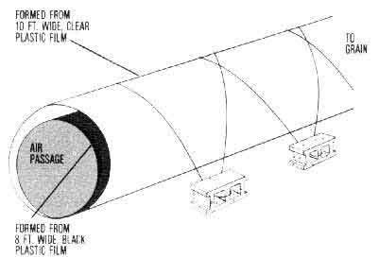

Figure 1. Example of a low-cost plastic collector.
A problem with plastic collectors is what to do with them when not in use. If left outside, the film is subject to damage or deterioration and must be replaced often; if stored inside, labor is required to set up and tear down the collectors. Also, they must be protected from livestock, pets and rodents. These disadvantages may offset their low cost.

Bare-Plate Collectors (Figure 2)
Bare-plate collectors are merely non-covered surfaces which absorb solar energy. Air flows through channels underneath and picks up the trapped heat.
An example of a bare-plate collector is a dark colored, metal-roofed building. The roofing sheets serve as the absorbing surface. Air channels beneath the roofing are made by enclosing the spaces between the rafters or girts with plywood, chipboard or insulation. This type of collector is simple and adapts to metal building construction, but is relatively low in collection efficiency (see Table 2).
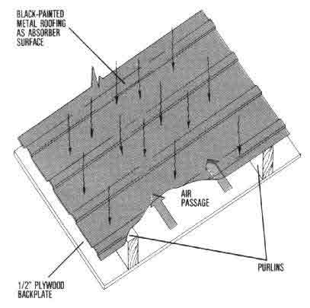

Figure 2. Section of a bare-plate collector.

Table 2. Efficiencies of Solar Collectors Used for Grain Drying.*
Type Percent efficiency
------------------------------------------------
Bare plate 15-30
Inflated plastic 20-40
Covered plate 30-50
Covered, suspended plate 40-60
------------------------------------------------
*Efficiency is the percent of sun's energy striking the collector that
is converted into heat. It depends on collector design and
orientation, air flow rate, protection from wind, amount of heat loss,
collector length vs. width, and temperature of air entering
collector (usually ambient for grain drying).

Covered-Plate Collectors (Figures 3-6)
Covered-plate collectors are more efficient than the bare-plate collectors. They can be free-standing, built into the buildings or placed on top of existing roofs. The `cover' allows the sun's rays to pass through to the black absorbing surface while protecting it from wind currents that would otherwise increase heat loss. The heat trapped and collected is carried off by the air flowing between the cover plate and absorbing surface (Figure 3).
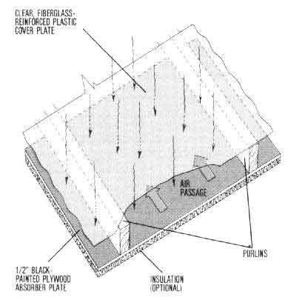

Figure 3. Section of a covered-plate collector.
To put a covered-plate collector on an existing roof, simply paint the roof black, place 2x2- or 2x4-inch wood strips or nailers on top of the roof to make channels for the air, and apply clear fiberglass or plastic over the wood strips (Figure 4.)
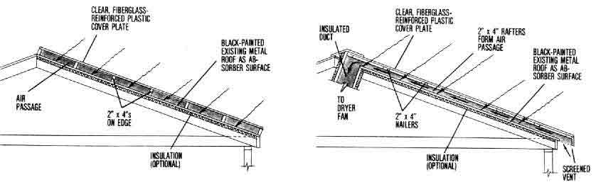

Figure 4. Alternative methods of adding a covered-plate collector to an existing metal roof.
In designing a new building, the metal exterior roof can be replaced with clear, fiberglass-reinforced plastic to serve as the cover and the entire attic space above the ceiling painted black to serve as the absorber (Figure 5). Or plywood or chipboard is used under the rafters or top truss member, with the side toward the sun painted black. Figure 6 shows a grain bin wall used as a covered-plate collector.
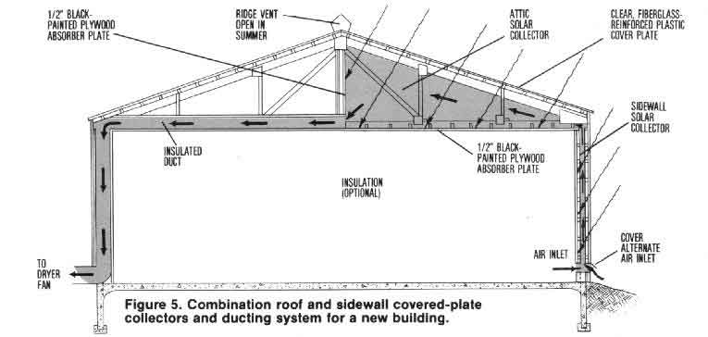
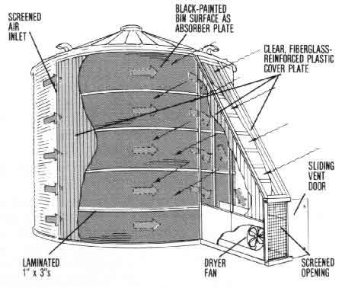

Figure 6. Using the grain bin wall as a covered-plate collector.

Suspended-Plate Collectors (Figures 7-8)
These are more efficient than the covered-plate types, because air flows on both sides of the blackened absorbing surface and less heat is lost (Figure 7). The back and side panels of the collector may be insulated, but the benefit of insulation in suspended-plate collectors used for low-temperature grain drying is small.
Most suspended-plate collectors are free-standing types, and the tilt is usually adjustable. Figure 8 illustrates a free-standing version.
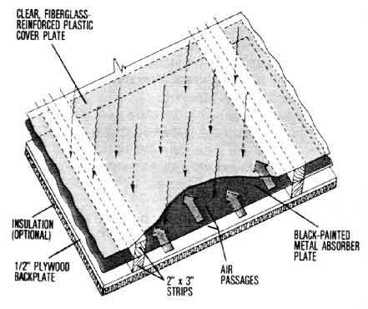

Figure 7. Section of a covered, suspended-plate collector.
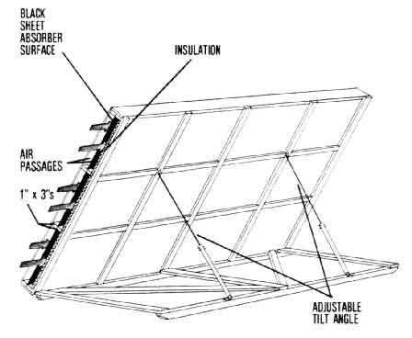

Figure 8. Free-standing, portable suspended-plate collector. (Side air inlet is screened.)

TRANSPORTING COLLECTED HEAT
Whether you collect solar energy in the roof or wall of a building, in the sidewall of the grain bin or in a free-standing collector, the solar heated air must be transported to the grain dryer. This can be done using part of the dryer fan energy to pull all or part of the drying air through the collector.
An air duct normally connects the collector to the dryer fan (Figure 5). If the collector is under a slight vacuum, air will flow into it through any leaks, and none of the collected heat will be lost.
It is not always feasible to move all the drying air through the collector, but rather to control the amount that flows through it. This can be done by building a `dog house' over the dryer fan and equipping it with a sliding door to blend outside air with heated air from the collector (Figure 9).
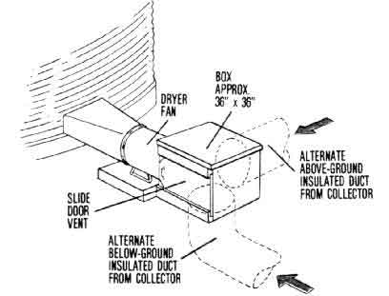

Figure 9. `Dog house' over the dryer fan to blend outdoor air with solar heated air.
A separate collector fan may be used to either push or pull the recommended amount of air through the collector. This air is then directed toward the air intake of the dryer fan, leaving space for outside air to be drawn into the fan along with solar-heated air (Figure 10). This system requires little management and can be automated by using a time clock to shut off the collector fan at night while the drying fan continues to operate using outside air.
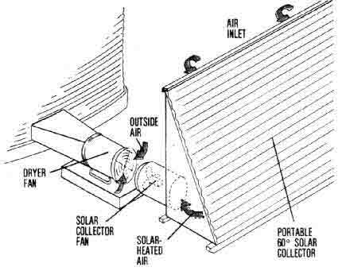

Figure 10. A separate collector fan directs solar heated air to the drying fan.
The static pressure required to move air through the solar collector should be limited to not more than 1/2 -inch of water column. The velocity of that air should not exceed 1000 feet per minute. Although more air through the collector increases collection efficiency, it takes more energy and pressure to move that increased air flow. Large drying fans turned on without some way to relieve the negative pressure in a roof collector have been known to cause the collector to collapse.
If a multi-purpose solar collector is used to heat a livestock or workshop area when not drying grain, the air velocity through the collector should be limited to about 500 feet per minute. The reason is that the low-pressure ventilation fans for environmental control are usually not designed to operate at static pressures as high as those encountered in grain drying. In addition, a low velocity will permit the air to be heated to a higher temperature.
For ducts, tunnels and conduits between the collector and fan on the grain bin, provide 1 square foot of duct cross-sectional area per 1 500 cubic feet of air volume. Keep ducts as straight as possible, avoiding sharp turns, and duct lengths as short as possible (preferably less than 100 feet); longer ducts require more horsepower to move the air and have more area for heat loss to occur. Also, insulate collector-to-fan ducts, unless they are located above ground and oriented east-west to serve as additional collector area.
One factor limiting the use of roof, sidewall or similar stationary collectors located on a building for drying grain in a nearby bin is the distance that the heated air has to be moved. The cost of ducting air more than 100 feet, together with the heat losses incurred, may make if more practical to use a separate or movable collector. Besides, a central collector may prevent efficient farm layout.

SIZING THE SOLAR COLLECTOR
Solar energy is used in grain drying mainly as a source of heat to supplement that in surrounding air. In full-bin drying, for instance, 50-70 percent of heat for drying comes from the heat already in natural air. An effective solar grain drying system should be able to add 20-40 percent more heat, with the fan contributing another 10-15 percent.
On an average October day, the sensible heat in the air (the heat you can `sense') raises the temperature about 10 degrees above dewpoint. That is, the temperature on the thermometer averages about 10 degrees above what it was in the early morning when dewfall occurred. This accounts for the 50-70 percent of the total drying energy that comes from natural air. The heat from solar energy. then, should be able to raise the temperature of the drying air by about 5 degrees, which represents 20-40 percent of the total heat needed.
How large a collector is needed to capture sufficient solar radiation for a 5-degree temperature rise? To find the answer, first we have to translate that 5 degree rise into heat units (BTUs) per bushel of grain being dried.
1. Assume that the drying air flow rate is 2 cubic feet per minute per bushel (cfm/bu.). The heat required to raise the temperature of 2 cfm of air 5 degrees averaged over a 24-hour day is estimated as follows (1.1 being a constant in the equation):
2 cfm/bu. x 5 F x 1.1 x 24 hrs. = 264 BTU/bu.-day
2. Now assume that a reasonably efficient collector oriented east-west and optimally tilted toward the sun will supply an average of about 700 BTU/sq.ft. of collector area each day during the fall drying season (October 15-November 15). Thus, the collector size needed per bushel of grain dried is calculated as follows:
264 BTU/bu. / 700 BTU/sq.ft. = 0.38 sq.ft./bu.
This is the way the values in Table 3 were determined. The range of collector sizes shown permits larger or smaller temperature increases from solar energy.
The data in Table 3 are a general guide for sizing solar collectors for drying grain. Differences in the sizes specified for the various types of collectors reflect their differences in collection efficiencies, as given in Table 2. The collector areas recommended for the four drying methods listed in Table 3 reflect either the difference in recommended drying air flow rates or temperature rises or both.

Table 3. Collector Area Required for Drying Grain by Selected Methods.¹
Collector type
Drying method (including Maximum ------------------------------------
needed air flow rate and initial Bare- Covered- Suspended-
desired temperature rise) moisture plate plate² plate
-------------------------------------------------------------------------
percent square feet per bushel

Full-bin/low-temperature 22 1/2 - 1 1/3 - 2/3 1/4 - 1/2
(2 cfm/bu. & 5 rise)

Full bin with stirring 24 1 - 4 2/3 - 3 1/2 - 2
(2 cfm/bu. & 10 rise)

Layer drying with stirring³ 26 4 - 10 3 - 7 2 - 5
(10 cfm/bu. & 10 rise)

Batch-in-bin⁴ 28 20 - 30 15 - 20 10 - 15
(15 cfm/bu. & 15 rise)
---------------------------------------------------------------------------
1 Based on average fall heat collection of 700 BTU/sq.ft for suspended plate collector.
2 Includes collectors built into or on building roofs and sidewalls.
3 Based on the number of bushels per layer.
4 Based on drying a 1000-bushel batch in 24 hours.

SOLAR GRAIN DRYING SYSTEM DESIGN--EXAMPLES
Here are examples of the procedure that might be followed in the design of a solar grain drying system. The examples are for full-bin/low-temperature and layer drying/grain stirring systems, and involve steps for determining the design requirements of collectors, collector air passages and supply ducts.

Full-Bin/Low-Temperature System
Situation. 4000 bushels of shelled corn at 22 percent moisture are to be dried down under this system, which requires a 2 cfm/bu. air flow rate and needs enough supplemental solar heat to provide a 5-degree temperature rise. The collector is a covered-plate type built into a building roof.
1. Collector area. For the covered-plate type collector. Table 3 suggests 1/3 - 2/3 square foot of surface area for each bushel of grain, when used for full-bin, low-temperature drying. Splitting the difference and using 1/2 sq.ft./bu., the total needed collector area at optimum tilt is:
1/2 sq.ft./bu x 4000 bu. = 2000 sq.ft.
2. Adjusted collector area. However, because the collector is on a 4/12-pitch roof, we need to adjust the-collector area to compensate for less-than-optimum tilt during the corn drying season. Table 1 shows that a collector at this tilt will provide only 85 percent as much heat in October as a collector with a 60-degree tilt; and only 75 percent as much in November-an average of 80 percent for the 2 months. Therefore, the collector size needs to be increased by 25 percent [(100% - 80%) / 80%]. Using this figure, we can calculate how much to increase the collector area to compensate for the `poorer' tilt angle:
2000 sq.ft. + (25% x 2000 sq ft.) = 2500 sq.ft
3. Collector dimensions. Suppose the building on which the collector is located is 48 ft. wide by 100 ft. long and oriented east-west. The area of the south-facing half of the roof is about 2600 sq.ft., which includes roof slope and overhang. To accommodate an area of 2500 sq.ft., the collector could be 25 ft. by 100 ft., or perhaps 24 ft. by 100 ft. to better utilize standard building material lengths.
4. Air flow through the collector. The total air flow volume needed for drying is: 4000 bu. x 2 cfm/bu. (from Table 3) = 8000 cfm. Therefore, the air flow rate passing through the collector will be:
8000 cfm / 2500 sq.ft. = 3.2 cfm/sq.ft.
An air flow through the collector of 5 cfm/sq.ft. is considered close to optimum for grain drying. Since 3.2 cfm is less, all the drying air available can be pulled or pushed through the collector. If the south half of the building attic space is painted black and used as the absorber, there would be plenty of room for air to flow through the collector. Provisions should be mace to vent the attic area used as a collector in the summer either with a ridge vent or louvered vents in each gable end.
5. Duct area and dimensions. As mentioned previously. the duct from collector to bin should be under 100 feet in length and have a cross-sectional area such that air velocity in the duct is 1500 fpm or less. Thus, for our example, required duct area is:
8000 cfm / 1500 fpm = 5.33 sq.ft.
To accommodate this required area, a round duct 32 inches in diameter or a rectangular duct about 2 ft. by 3 ft. may be used.

Layer Drying System with Grain Stirring
Situation. 4500 bushels of shelled corn at 25 percent moisture are to be dried down in three layers (1500 bushels each) using this system, which calls for a 10 cfm/bu. airflow rate and a 10-degree temperature rise provided by solar heat. The collector is a suspended-plate type, free-standing and tilted during the drying period at an optimum 60 degrees.
1. Collector area. Table 3 shows that, for this type of drying system, a 10-degree temperature input is recommended from solar heat, requiring a suspended-plate collector area of 2-5 sq.ft./bu. Again. using the mid-point for our example, total collector area needed is found to be:
3.5 sq.ft./bu. x 1500 bu. = 5250 sq.ft.
2. Collector dimensions. A collector this large could be made up of three sections, each 12 ft. wide and about 144-148 ft. long (1750 sq. ft.) manifolded together to provide the 5250 sq.ft. needed.
3. Air flow through the collector. The total air volume needed for drying is: 1500 bu. x 10 cfm/bu. = (from Table 3) 15,000 cfm. Thus, the air flow rate through the collector must be:
15,000 cfm / 5250 sq.ft = 2.9 cfm/sq.ft.
While this is lower than the optimum amount of near 5 cfm/sq.ft., air flow must be limited to insure a 10F average temperature rise in the drying air. Thus, all the drying air can be pulled through the collector if air velocity and static pressures do not exceed recommended levels.
4. Area and dimensions of air channel through collector. First, we must find the total air flow rate in each section of the collector:
2.9 cfm/sq.ft. x 1750 sq.ft. = 5075 cfm.
If we keep air velocity through the collector within the recommended 500-1000 fpm range (750 fpm average), the required air channel area in each section will be:
5075 cfm / 750 fpm = 6.8 sq.ft.
Since each collector section is 12 ft. wide, the depth of the air channel must be:
6.8 sq.ft. / 12 ft. = .57 ft. or about 7 in.
Since air is drawn through both sides of the absorber In a suspended-plate collector, the air passage will be 3 1/2 inches deep on each side. This would allow you to use standard 4-inch lumber (which is actually 3 1/2 inches) on each side of the absorber.
5. Duct area and dimensions. Again, holding to the 1500 fpm air velocity maximum in the supply duct from the collector to the drying fan, we calculate cross-sectional area as follows:
15.000 cfm total drying air
--------------------------- = 10 sq.ft.
1500 fpm velocity
A rectangular duct 2.5 ft. wide by 4 ft. high would be adequate, if the duct is very long, consider making it triangular and using the leg of the triangle which faces the sun as additional collector area.

SUMMARY OF MANAGEMENT CONSIDERATIONS IN SOLAR DRYING
Following is a summary of how solar energy may be applied to grain drying, including management tips to help insure success:
* Solar energy is an excellent alternative source of supplemental heat for low-temperature grain drying systems. Because these systems require only a few degrees additional temperature rise 5-10 F, they are well adapted to the moderate heat increases that solar energy can economically generate. Also, if the temperature rise during midday is substantially above this, the grain will store the excess heat and release it during the night, allowing no drying process to continue.
* The initial moisture level of corn to be dried in a full-bin drying system should not be more than 22 percent, because of the limitations on fan power and air flow, not because of insufficient heat from solar energy. Higher initial moisture contents are permitted if the grain can be stirred or dried in layers or dried in smaller batches at higher air flow rates.
* Solar energy may be used in the low-temperature phase of a combination drying system after the grain is dried to 20-22 percent in a high-speed dryer.
* Continuous drying is best until the moisture content is 15 percent in full-bin systems. Intermittent operation in daytime only may be necessary to reduce the moisture below 15 percent.
*If binned grain is not completely dry but is down to 18 percent of lower moisture by early December, the damp grain can be maintained through the winter by occasional aeration for temperature control. Drying may then be completed the next spring when the humidity is lower and more solar heat is available. If any grain in the bin is above 18 percent moisture, drying must be continued until the wet grain either dried or is fed.
* It is best that the drying air bypass the collector at night. If not, the collector will radiate heat to the cold night sky and cool to below the surrounding temperature any drying air pulled through it. Taking air directly into the dryer fan eliminates the collector's air flow resistance, thus improving drying capacity and saving energy.
* Be sure to provide summer ventilation for solar collectors, especially roof and attic types, to prevent high temperature buildup. Ridge ventilators, gable-end louvers and eave openings will accomplish this. High temperatures cause deterioration of collector fiberglass cover plates and insulation.
* The importance of sealing cracks in the solar collector and distribution system depends on whether the air is pushed or pulled. If pulled, air entering the collector will only reduce the temperature, not the amount of total heat collected and delivered. If air is pushed and the collector and duct system are under pressure, any air leaking from the system is heat lost. This is why pulling air through the collector is preferred.
* Insulate distribution ducts that will lose heat to the outside air or ground with at least 1 inch of insulation to conserve collected heat.
* Cover all air intake openings with 1/4-inch hardware screen to keep out birds and rodents, and practice a good rodent control program.
* If you use the solar grain drying system alternately for livestock space heating and your building roof serves as a solar collector, do not reverse the air through the collector for summer cooling. If you do, odors and dust from the livestock area will be drawn into the collector. Later, when the collector is used again for grain drying, these odors may be transmitted into the grain. Use a separate ventilation system to cool the collector in summer.
* If you build a collector into a machinery shed roof or sidewall, take air into the collector from inside the structure. Inside air warmed by heat radiating from the back side of the collector will be utilized, but provision must be made for air entrances.
* Limit air velocities to about 1000 fpm through the air passages of bare-plate collectors and to 500-1000 fpm through covered- or suspended-plate collectors. Allow 1 square foot of duct cross-section per 1500 cfm of air volume in tunnels and ducts connecting the collector to the dryer fan.

Related Publications
Single copies of the following Purdue Extension Publications are available free to Indiana residents from their county Cooperative Extension Service office or by writing to Media Distribution Center, 301 South Second Street, Lafayette, IN 47901-1232:
"Fan Sizing and Application for Bin Drying/Cooling of Grain" (AE-106)
"Solar Energy Heat Storage for Home, Farm and Small Business" (AE-89)
"Solar Heating for Home, Farm and Small Business" (AE-88)
"Solar Heating Systems for Confinement Livestock Buildings" (AE-99)
The following Midwest Plan Service publication is available at the per-copy cost indicated (1980 price) from the Farm Building Plan Service, Agricultural Engineering Department, Purdue University, West Lafayette, IN 47907:
"Low-Temperature and Solar Grain Drying Handbook" (MWPS-22), $3.00
For more information, contact Dirk Maier, Agricultural and Biological Engineering, phone: 317-494-1175 or e-mail: maier@ecn.purdu

Don D. Jones and William H. Friday
Extension Agricultural Engineers,
Purdue University

A mechanically-ventilated confinement livestock building must have properly-sized fans, furnaces and slot air inlets it it is to operate satisfactorily. This worksheet was developed to help producers and builders calculate the capacities and dimensions of equipment needed tor specific livestock buildings. It should be used in conjunction with Purdue Extension Publication AE-96, "Environmental Control tor Confinement Livestock Housing," which deals with the principles and design of commonly-used environmental control systems.
This worksheet leads you through a step-by-step procedure for calculating the needs of an exhaust ventilation system, by tar the type most commonly used today. For design information onpositive and combination positive/negative ventilations systems, consult publication AE-96.
An example situation is presented to illustrate the types of calculations involved and how they are `worked.' Be sure you understand where the various input figures come from, why they were used and how the answers were arrived at before applying the worksheet to your particular building. Some of the input data needed for the calculations are provided in Tables 1-4 which follow. At the end of the worksheet is a brief summary and information on sources of related publications and computer programs.

Table 1. Recommended Per-Head Ventilation Rate for Confinement Swine and Dairy.

Cold weather rates
--------------------------------------------
For moisture control on-
----------------------- Added for For Mild Hot
Type of Fully Partly Solid unvented odor weather weather
animal or facility slotted slotted floor heaters* control rates rates
-------------------------------------------------------------------------------------------
cubic feet per minute
Swine
Sow and litter 10 17 20 4 35 80 325
Pre-nursery pig (12-30 lb.) 1 1.6 2 0.5 3.5 10 25
Nursery pig (30-75 lb.) 1.5 2.5 3 0.5 5 15 35
Growing pig (75-150 lb.) 3.5 5.5 7 1.0 10 24 75
Finishing hog [150-220 lb.) 5 8 10 - 18 35 120
Gestation sow (325 lb.) 6 10 12 1.0 20 40 150
Boar (400 lb.) 7 12 14 2.8 24 50 180

Dairy
Cow 16.5 28 33 - 50 130 600
Calf 5 8.5 10 2 16 25 150
Milk rooms (total cfm) - - 8 - - 25 50
Parlors (total cfm) - - 8 - - 25 100
--------------------------------------------------------------------------------------------
* Increase the fully-slotted, partly-slotted and solid floor moisture
control rates by these amounts it unvented heaters are used

Table 2. Likely Supplemental Space Heat Requirements per Animal Unit for Confinement Swine and Dairy Calves.*
Supplemental
heat
---------------
Inside Slotted Solid
Animal unit temp. floor floor**
------------------------------------------------------
BTU/hr.

Sow and litter 60 F - 3500
70 F 3000
80 F 4000

Pre-nursery pig (12-30 lb.) 80 F 350 -

Nursery pig (30-75 lb.) 65 F - 450
75 F 350
Growing pig (75-150 lb.) 60 F 600

Gestation sow and boar 60 F 500

Dairy calf 70 F 1000 1000
------------------------------------------------------
* Sized for the odor control ventilation rate in a moderately
well-insulated building. Additional creep heat will be needed for
young animals in farrowing and nursery; size creep heaters at about
halt the space heat needs shown.

** Solid floor scraped and bedded periodically.

Table 3. Temperature Optimums and Ranges for Confinement Swine and Dairy Animals.
Temperature
-----------------
Type of animal Optimum Range
----------------------------------------------
Swine
Lactating sow 60 F 50- 70 F
Litter, newborn 95 F 90-100 F
Litter, 3 weeks 75 F 70- 80 F
Pre-nursery pigs
(12-30 lb.) 80 F 75- 85 F
Nursery pigs (30-75 lb.) 75 F 70- 80 F
Growing/finishing hogs 60 F 50- 70 F
Gestation sow and boar 60 F 50- 70 F
Dairy
Cows 50 F 45- 70 F
Calves 70 F 45- 80 F
----------------------------------------------

Table 4. Speeds and Capacities of Various Size Commercial Ventilation Fans.
Diameter Speed Capacity
in inches Horsepower in rpm in cfm*
------------------------------------------
Single- and multiple-speed fans

7 1/20(2-speed) 1550 30
3000 150
8 1/20(2-speed) 1550 80
3000 450
10 1/6(2-speed) 1550 375
3000 950
10 1/28 3000 600
------------------------------------------
12 1/6 1725 1000
14 1/4 1725 1600
16 1/4 1725 2400
------------------------------------------
18 1/4 1725 3000
20 1/3 1725 3200
24 1/2 770 5000
30 1/2 600 8000
136 3/4 545 11,000
48 1 525 18,000
------------------------------------------
Max. Min. Max.
Variable speed fans rpm cfm cfm

12 1/10 1700 250 850**
14 1/8 1750 110 1600
16 1/3 1725 850 2250
18 1/3 1600 500 3500
24 1/3 1050 800 4500
36 1/2 800 600 8000
------------------------------------------
* All single-speed capacities shown are at 1/8 or 1/10 inch water
pressure.

** Maximum cfm is at 1/12 inch water pressure.

WORKSHEET WITH EXAMPLE SUMMARY
Example situation. Determine the heating and ventilation needs for environment control of a 24- by 84-foot, total-slotted floor farrowing house containing 30 sows and litters (Figure 1). Assume that the desired room temperature is to be 72 F, and that the building was properly constructed and insulated. (See AE-95, `Insulating Livestock and Other Farm Buildings," for recommended insulation levels in environmentally-controlled buildings.)
A. User's identification.
1. Name: William H. Jones
2. Address: Homestead Farms, Lafayette, IN
B. Building information

Our Your
example value

1. Building size (width X length): 24' x 84' __________

2. Type of livestock facility (farrowing, dairy freestall, etc.): Farrowing __________

3. Floor type (slotted, partly-slotted or solid): Slotted __________

4. Number of animals (count sow and litter as one): 30 __________

5. Type of space heating system (vented or unvented): Unvented __________

C.Recommended ventilation rates (from Table 1) and space heating rate (from Table 2) per animal unit.
Remember to increase the moisture control ventilation rate it an unvented heater is used. For example, from Table 1, each sow and litter on a total-slotted floor would require a moisture control rate of 10 cfm + 4 cfm = 14 cfm.
Our Your
example value
1. Moisture control ventilation rate, cfm: 14 _________

2. Odor control ventilation rate, cfm (optional): 35 _________

3. Mild weather ventilation rate, cfm: 80 _________

4. Hot weather ventilation rate, cfm: 325 _________

5. Space heating rate, BTU/hr.:* 3000 _________
* Size creep heat needs as indicated in AE-96. For purposes of this worksheet, creep heat is not considered part of the space heating system, but rather as a separate unit required for producing a microclimate for pig comfort.
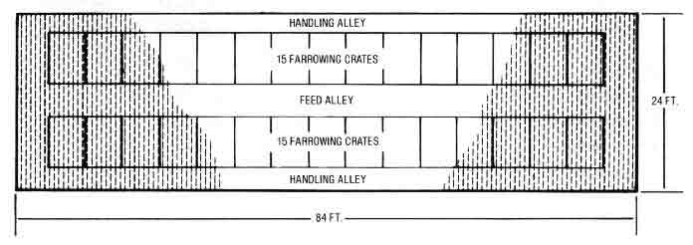

Figure 1. Plan view of 30-sow farrowing house used in example.
D.Total recommended ventilation and heating rates.
Total requirement = rate per animal unit (Step C) X number of animal units (Step B.4). If two sizes of animals are housed, calculate the value required for the animals of each size, and combine to get the total quantity required.
Our example
1. Moisture control rate X No. of animals: 14 X 30 = 420 cfm

2. Odor control rate X No. of animals: 35 X 30 = 1050 cfm

3. Mild weather rate X No. of animals: 80 X 30 = 2400 cfm

4. Hot weather rate X No. of animals: 325 X 30 = 9750 cfm

5. Space heating rate X No. of animals: 3000 X 30 = 90,000 BTU/hr.

Your values
1. Moisture control rate x No. of animals: _________ x _________ = _________ cfm

2. Odor control rate x No. of animals: _________ x _________ = _________ cfm

3. Mild weather rate X No. of animals: _________ x _________ = _________ cfm

4. Hot weather rate X No. of animals: _________ x _________ = _________ cfm

5. Space heating rate X No. of animals: _________ x _________ = _________ BTU/hr.
E.Fan size selection (from Table 4 or obtain values from local fan dealers)

(a) (b) (c) (d)
Additional Total fan
Total cfm needed Fan size for capacity
recommended (col.a - col.d additional (sum of
ventilation from pre- cfm needed fan sizes
rate (Step D) vious line) (Table 4) in col.c)
Our example

1. Moisture control: 420 ----- 375/950 375-\ 2 sp

2. Odor control (optional): 1050 675 375/950 950-/ fan

3. Mild weather: 2400 1450 1600 2550

(Additional fan): (____) (_____) (_____)

4. Hot weather: 9750 7200 2400 4950

(Additional fans): (4800) (6000) (9950)

Your values

1. Moisture control: _______ ________ ________ ________

2. Odor control (optional): _______ ________ ________ ________

3. Mild weather: _______ ________ ________ ________

(Additional fan): (_____) (_____) (_____)

4. Hot weather: _______ ________ ________ ________

(Additional fans): (_____) (_____) (_____)

F.Thermostat settings for furnace and fans.
Fans are those selected in Step E, col.c. Assume an on-off range of 5 F for furnace thermostat if actual range is unknown (see "Determining Fan Size and Thermostat Settings" in AE-96). Set mild and hot weather fans to come on in 2-4 F increments, starting about 3 F above the odor control fan setting (or furnace off-temperature if an odor control fan is not used).
1. Settings for furnace thermostat.
a.Desired room temperature (see Table 3).

Our example: 72 F

Your value:_________ F

b.Furnace on-temperature = Desired temperature (Step F.1.a) - 2 F.

Our example: 72 F - 2 F = 70 F

Your value:__________F - 2 F = __________F

c.Furnace off-temperature = on-temperature (Step F.1.b) + on-off
range (5 F if unknown).

Our example: 70 F + 5 F = 75 F

Your value:________ F + ________ F = ________F
2. Setting for moisture control fan (from Step E.1 ,col.c) --should be operated continuously or off at 40F to prevent water pipe freezing.
Our example: 375 cfm, off at 40 F

Your value: cfm, off at __________ F
3. Setting for optional odor control fan (from Step E.2, col.c) = furnace off-temperature (Step F.1.c) + 3 F (thermostat wired in parallel with switch or timer control to allow manual operation).
Our example: 75 F + 3 F = 78; 1000 cfm, on at 78 F

Your value: ________ F + 3 F = ______; _________ cfm, on at _________ F
4. Settings for mild weather fans (from Step E.3, col.c)-see Step F instructions above.
Our example: 1600 cfm, on at 81 F

(________) cfm, on at _________ F)

Your values:__________cfm, on at _________ F

(_______) cfm, on at _________ F)
5. Settings for hot weather fans (from Step E.4, col.c)-see Step F instructions above.
Our example: 2400 cfm, on at 84 F

( 5000 cfm, on at 87 F)

(______)cfm, on at _________F)

Your values:__________cfm, on at __________F

(_______)cfm, on at _________F)

(_______)cfm, on at _________F)
G.Slot air inlet length.
1.Fan bank clearance -i.e.,the wall length around the sidewall fans where no slot air inlets or soffit air intakes are located (Figure 2). If air inlet widths are adjusted with an automatic controller, fan bank clearances may not be necessary. In such cases, Step G.1=0.
Grouping fans in one location maximizes air inlet length for best air distribution. Locate fans so that air is not pulled more than 75 feet to prevent short circuiting (i.e., pulling stale exhausted air back into the building or exhausting incoming air before it has a chance to be evenly distributed around the room).
Fan bank clearance = the wall length occupied by the fans plus an additional 8-foot clearance on each side of the fan location. In new buildings, plan for a fan bank clearance of 16 feet for single-fan installations and (number of fans X 6-foot fan spacing) + 16 feet for multiple-fan installations. Only sidewall fans, usually for mild and hot weather, are used in calculating fan bank clearance. Pit fans are normally far enough below the slot air inlet to have no effect, unless an elevated exhaust is used.
The following calculations assume only one fan bank. If more than one fan location is used, simply sum the clearances for each fan location to determine total fan bank clearance.
a. New system single wall fan clearance = 2 X 8 ft. on each side of fan = 16 ft.

b. New system multiple installation fan bank clearance =
(no. of fans X 6 ft.) + 16 ft.

Our example:(3 fans X 6 ft.) + 16 ft. = 34 ft.

Your value:(___________ X 6 ft.) + 16 ft. = ___________ ft.

c. Existing system fan bank clearance = fan bank length + 8
ft. clearance on each side.

Your value: __________ ft. + (8 ft. X 2) = __________ ft.
2.Total slot air inlet length and location (Figure 3).
a. Inlet length for buildings up to 36 feet wide (inlets located
along each sidewall) = [2 x building length (Step. B.1)] - fan bank
clearance (Step G.1).

Our example: (2 X 84 ft.) - 34 ft. = 134 ft.

Your value: (2 x ___________ ft.) - ___________ ft. = ___________ ft.

b.Inlet length for buildings 36-60 feet wide (double-sided center
slot inlet system and slot inlets along each sidewall) = [4 X building
length (Step B.1)] - fan bank clearance (Step G.1).

Your value: (4 X ___________ ft.) - ___________ ft. = ___________ ft.

c. Inlet length for buildings over 60 feet wide (two double-sided
slot inlets evenly spaced across the ceiling and slot inlets along
each sidewall) = [6 X building length (Step B.1)] - fan bank clearance
(Step G.1).

Your value: (6 X ___________ ft.) - ___________ ft. = ___________ ft.
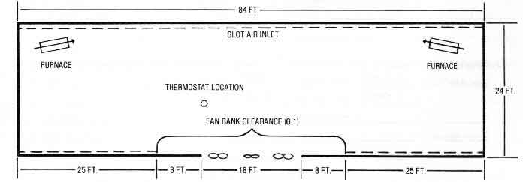

Figure 2. Fan bank clearance for single- and multiple-fan installations.
H. Width of slot air inlets (Figure 4).
1. Maximum ventilation rate per toot of inlet = total hot weather rate fan capacity (Step E.4, col.d) total slot length (Step G.2):
Our example: 9950 cfm / 134 ft. = 74.25 cfm/ft.

Your value: __________cfm / _________ ft. = ___________ cfm/ft.
2. Maximum slot width = maximum ventilation rate per foot of inlet (Step H.1)/ 50 cfm/in. of slot width per foot of length (since 1 in. wide opening provides 50 cfm/ft. of length).
Our example: 74.25 cfm/ft. / 50 cfm/in.-ft. = 1.5 in.

Your value: __________ cfm/ft. / 50 cfm/in.-ft. = _______ in.
3. Minimum ventilation rate per foot of inlet = moisture control rate fan capacity (Step E.1, col.d) / total slot length (Step G.2).
Our example: 375 cfm / 134 ft. = 2.8 cfm/ft.

Your value: ________ cfm / _______ ft. = ________ cfm/ft.
4. Minimum slot width = minimum ventilation rate per foot of inlet (Step H.3) / 50 cfm/in. per foot of length.
Our example: 2.8 cfm/ft. / 50 cfm/in.-ft. = 0.06 in.* (use 1/8 in.)

Your value: __________ cfm/ft. / 50cfm/in.-ft. = __________ in.*
*An adjustable baffle is needed to close down the inlet to this width.
J. Attic and soffit air intakes (Figure 4).
Size on the basis of 2 cfm per square inch of free opening. Increase opening sizes accordingly it shutters or wire mesh screens are placed over the openings.
1. Soffit openings, sized for hot weather ventilation. Provide closures for cold weather ventilation. (Soffit openings are not needed in the fan bank clearance area).

a.Soffit length = [2 X building length (Step B.1)] - fan bank clearance (Step G.1).

Our example: (2 X 84 ft.) - 34 ft. = 134 ft. (X 12 in./ft. = 1608 in.)

Your value: (2 X _____ ft.) - _________ ft. = _________ ft. (X 12 in./ft. = _________ in.)

b.Soffit area = total hot weather rate fan capacity (E.4, col.d) / 2
cfm per square inch of opening (see Step J instructions).

Our example: 9950 cfm / 2 cfm/sq.in. = 4975 sq.in.

Your value: __________ cfm / 2 cfm/sq.in. = __________ sq.in.

c.Minimum width of soffit opening = soffit area (Step J.1.b) /
soffit length (Step J.1.a).

Our example: 4975 sq in. / 1608 in.= 3.09 in.

Your value: ________ sq in. / _________ in.= _________ in.

2. Total area of louvered openings in attic gables and ridge openings = mild weather rate fan capacity (Step E.3, col.d) / 2 cfm per square inch of opening.
Our example: 2550 cfm / 2 cfm/sq.in. = 1275 sq.in. (or about 9 sq ft.)

Your value: _________ cfm / 2 cfm/sq.in. = _________ sq.in.
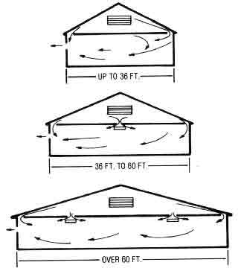

Figure 3. Slot air inlet locations for building of various widths.
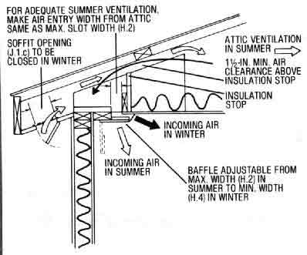

Figure 4. Suggested slot air inlet design.

SUMMARIZING THE EXAMPLE RESULTS
Design of environmental control systems for livestock buildings is not an exact science. As pointed out in publication AE-96 and illustrated in this worksheet, the goal should be to obtain a system which will provide productive, efficient environmental conditions.
A livestock environment which is a degree or two from optimum won't make much difference in terms of animal performance. However, since energy use is directly related to design and operation of the environmental control system, livestock producers should try to estimate as nearly as possible and purchase properly sized equipment, then manage it efficiently to maintain the desired environment at a minimum expense.

Related Information
Single copies of the following "Energy Management in Agriculture" publications are available free to Indiana residents from their county Cooperative Extension Service office or by writing to Media Distribution Center, 301 S. 2nd St., Lafayette, IN 47901-1232.
"Environmental Control for Livestock Housing" (AE-96)
"Insulation of Livestock & Other Farm Buildings" (AE-95)
"Methane Generation from Livestock Waste" (AE-105)
"Natural Ventilation for Livestock Housing" (AE-97)
"Pit Ventilation Systems for Livestock Housing" (AE-98)
"Planning Farm Shops for Work and Energy Efficiency" (AE-104)
"Solar Heating Systems for Livestock Buildings" (AE-99)
"Troubleshooting Mechanical Ventilation Systems" (AE-100)
"Wind and Snow Control for the Farmstead" (AE-102)
Also, a FACTS computer program, entitled Ventilation and Energy Needs Tabulation is available at county Extension offices which can be used to calculate ventilation needs in environmentally-controlled livestock buildings. Although the program does not provide as much specific design information as this worksheet, it does allow the user to experiment with the effects that various building temperatures, ventilation rates, animal densities and insulation levels would have on building heating costs.

New 9/80
Cooperative Extension work in Agriculture and Home Economics, state of Indiana, Purdue University, and U.S. Department of Agriculture cooperating; HA. Wadsworth, Director, West Lafayette. IN. Issued in furtherance of the acts of May 8 and June 30, 1914. Purdue University Cooperative Extension Service is an equal opportunity/equal access institution

Comparable Costs of Various Energy Sources for Irrigation Pumping

Rolland Z. Wheaton and Edwin J. Monke
Department of Agricultural Engineering, Purdue University

Because of continued rising prices of petroleum products, many irrigators are looking more closely at the comparative costs of various energy sources for irrigation pumping. The purpose of this publication is not only to provide such a comparison, but also to alert you to other factors that must be considered in selecting a particular energy source.

Performance Standards for Various Energy Forms
From Nebraska Test data, standards have been developed for the horsepower-hours that engines or motors should produce using four different energy forms--gasoline, diesel fuel, propane gas and electricity. (A horsepower-hour is 1 horsepower produced continuously for 1 hour.) The results are shown in Table 1.
These standards are the best that can be expected for engines operating at 85 percent and electric motors operating at 100 percent of their horsepower ratings. If loadings are reduced below these percentages, the standards must also be reduced. For continuous operation, recommended loadings are 80 percent of maximum horsepower ratings for water-cooled engines, 65 percent for small air-cooled engines and 100 percent for electric motors.

Table 1. Horsepower-Hours of Work Output per Unit of Energy Input for Various Power Units.
Unit of
Power Unit energy input Work output
----------------------------------------------------
Gasoline engine Gallon 11.3 horsepower-hour
Diesel engine Gallon 14.7 horsepower-hour
Propane engine Gallon 8.92 horsepower-hour
Electric motor Kilowatt-hour 1.18 horsepower-hour
----------------------------------------------------

Determining Comparable Costs
The above standards were used to calculate the amount that can be paid for each of the energy sources to obtain an equal number of horsepower-hours per dollar spent. The price figures are presented in Table 2. However, they are only for the energy purchased, and do not take into account such factors as initial cost, maintenance requirements, convenience, energy availability and dependability of service.

Table 2. Comparative Costs of Various Energy Sources to Obtain Equal Work Output per Dollar Spent.
Gasoline Diesel fuel Propane gas Electricity
(gallon) (gallon) (gallon) (kilowatt-hour)
----------------------------------------------------
cents
.60 .78 .47 6.3
.70 .9l .55 7.3
.80 $1.04 .63 8.4
.90 1.18 .71 9.4
$1.00 1.31 .79 10.4
1.10 1.44 .87 11.4
1.20 1.57 .95 12.5
1.30 1.70 $1.03 13.5
1.40 1.83 1.11 14.6
1.50 1.97 1.19 15.6
1.60 2.10 1.26 16.7
1.70 2.23 1.34 17.7
1.80 2.36 1.42 18.7
1.90 2.49 1.50 19.8
2.00 2.62 1.58 20.8
----------------------------------------------------
To compare costs between the different sources, find the applicable price for one source and read horizontally across the table. For example, at $1.00 per gallon for gasoline, an irrigator could afford to pay $1.31 per gallon for diesel, 79 cents per gallon for propane, or 10.4 cents per kilowatt-hour for electricity to get equal work output. Again, these `comparable' prices are for the purchase of energy only.

Special Considerations in Evaluating Electricity
To more accurately evaluate electric power, three important factors must not be overlooked--availability of an adequate source, line extension charges and minimum monthly or annual charges.
For instance, since most irrigation pumping only occurs over a 3-4 month period in Indiana, such short-term use is often subject to extra charges that can greatly influence the total cost. In fact, some irrigators have found that stand-by charges nearly equal the total charge for kilowatt-hours purchased, in effect doubling the unit price.
Each case will vary, so it is important that, initially, pricing structure and other arrangements be worked out with the electrical supplier.

Summary
Comparable cost--now and in the future--is a major consideration in selecting an energy source for irrigation pumping. But questions of availability, dependability and required maintenance must also be answered before finalizing your decision.

New 9/80
Cooperative Extension work in Agriculture and Home Economics, State of Indiana, Purdue University and U.S. Department of Agriculture cooperating: H.A. Wadsworth, Director, West Lafayette, IN. Issued in furtherance of the acts of May 8 and June 30, 1914. The Cooperative Extension Service of Purdue University is an equal opportunity/equal access institution.

